A

Project Report on

“Online Food Ordering System”

SUBMITED BY

Miss. Lagad Reshma Rajendra

Guide BY

Prof. Borade A.B

SUBMITED TO

SAVITRIBAI PHULE PUNE UNIVERSITY

IN PARTIAL FULLFILMENT OF

T.Y.B.Sc (Computer science)

SHRI CHHATRAPATI SHIVAJI MAHAVIDYALAYA SHRIGONDA, DIST-A-NAGAR, PIN 413701

ACADMIC YEAR-2021-2022



SHRI CHHATRAPATI SHIVAJI MAHAVIDYALAYA

SHIVAJINAGAR, SHRIGONDA-413701, DIST- AHMEDNAGAR

Date: / /2022.

**CERTIFICATE OF PROJECT COMPLETION**

**Certified that Project/Field work Report titled**

**“Online Food Ordering System”**

Has been completed satisfactory in partial fulfillment of B.Sc. (Computer Science), Course of **“SAVITRIBAI PHULE PUNE UNIVERSITY”** for the academic Year 2021-2022 by the following student of **“SHRI CHHATRAPATI SHIVAJI MAHAVIDYALAYA”,** SHRIGONDA.

**Name of the Student – Miss.** Lagad Reshma Rajendra

**Place:** SHRIGONDA

### **Principle**

S.C.S.M, SHRIGONDA

### **Seen BY –**

### **Internal Examiner Sign** **External Examiner Sign**

**ACKNOWLEDGEMENT**

We have immense pleasure in presenting the report for our project entitled “ONLINE FOOD ORDERING SYSTEM”.

We would like to take this opportunity to express our gratitude to a number of people who have been sources of help & encouragement during the course of this project.

We are very grateful and indebted to our project guide Ms. Gholap S. & Ms. Girme A. our respected HOD Mr. Borade A.B for providing their enduring patience, guidance & invaluable suggestions. They were the one who never let our morale down & always supported us through our thick & thin. They were the constant source of inspiration for us & took utmost interest in our project.

We would also like to thank all the staff members for their invaluable co-operation & permitting us to work in the computer lab.

We are also thankful to all the students for giving us their useful advice & immense co- operation. Their support made the working of this project very pleasant.

**INDEX**

|  |  |  |
| --- | --- | --- |
| **Sr. No.** | **Name of Topic** | **Page No.** |
| 1. | **1. Introduction**  A. Motivation  B. Problem Statement  C. Purpose / Objectives and Goals  D. Literature Survey  E. Scope  F. Limitations |  |
| 2. | **2. System Analysis**  A. Existing System  B. Scope and Limitation of Existing System  C. Project Perspective and Features  D. Stakeholders  E. Requirement Analysis |  |
| 3. | **3. System Design**  A. Using an OOSE  B. Using Data Model  C. Using User Interface |  |
| 4. | **4. Implementation Details**  A. Software and Hardware Specifications |  |
| 5. | **5. Outputs and Report Testing**  A. Black Box Testing  B. White Box Testing |  |
| 6. | **6. Conculsion** |  |
| 7. | **7. Future Scopes and Recommendations** |  |
| 8. | **8. Biblography and References** |  |

**1. INTRODUCTION**

ONLINE FOOD ORDERING SYSTEM is mainly designed primarily

Function for use in the food delivery industry. This system will allow

hotels and restaurants to increase online food ordering such type of

business. The customers can be selected food menu items just few

minutes. In the modern food industries allows to quickly and easily

delivery on customer place. Restaurant employees then use these

orders through an easy to delivery on customer place easy find out

navigate graphical interface for efficient processing.

**A. MOTIVATION**

The motivation for designing this application came because –

1. In Today’s life, Every small business needs to be brought online for

business growth and customer convenience.

2. Using this application Customer’s can order their food from any

restaurant .

3. This System increases the takeaway of foods than visitors.

4. This System enhances the Speed and Standardization of taking the

order from the customer.

**B. PROBLEM STATEMENT**

1. In this system, I will provide Online Delivery to our Customers
2. Firstly, I will collect the data from the Customer through the

Registration form and Customer’s order food through application.

1. I will confirmed the order by sending a confirmation text to the

customer.

1. With the help of Delivery Boy I will deliver the food to the customers.
2. Customers will be able to rate according to their experience,

recommend some changes and improvements to the current system.

1. Multiple modes of payment will be provided while ensuring safe

and secure online transactions.

**C. PURPOSE / OBJECTIVES AND GOALS**

1. To build an application program based on the client server

application to reduce the manual work for managing the Food

Items, Customers, Accept Orders and Payment.

1. To develop easy way for Customers to Order Food and pay

online/offline.

1. The main purpose is that Increased Customers, Reduced Time

Consumption and Greater Speed and Accuracy.

**D. LITERATURE SURVEY**

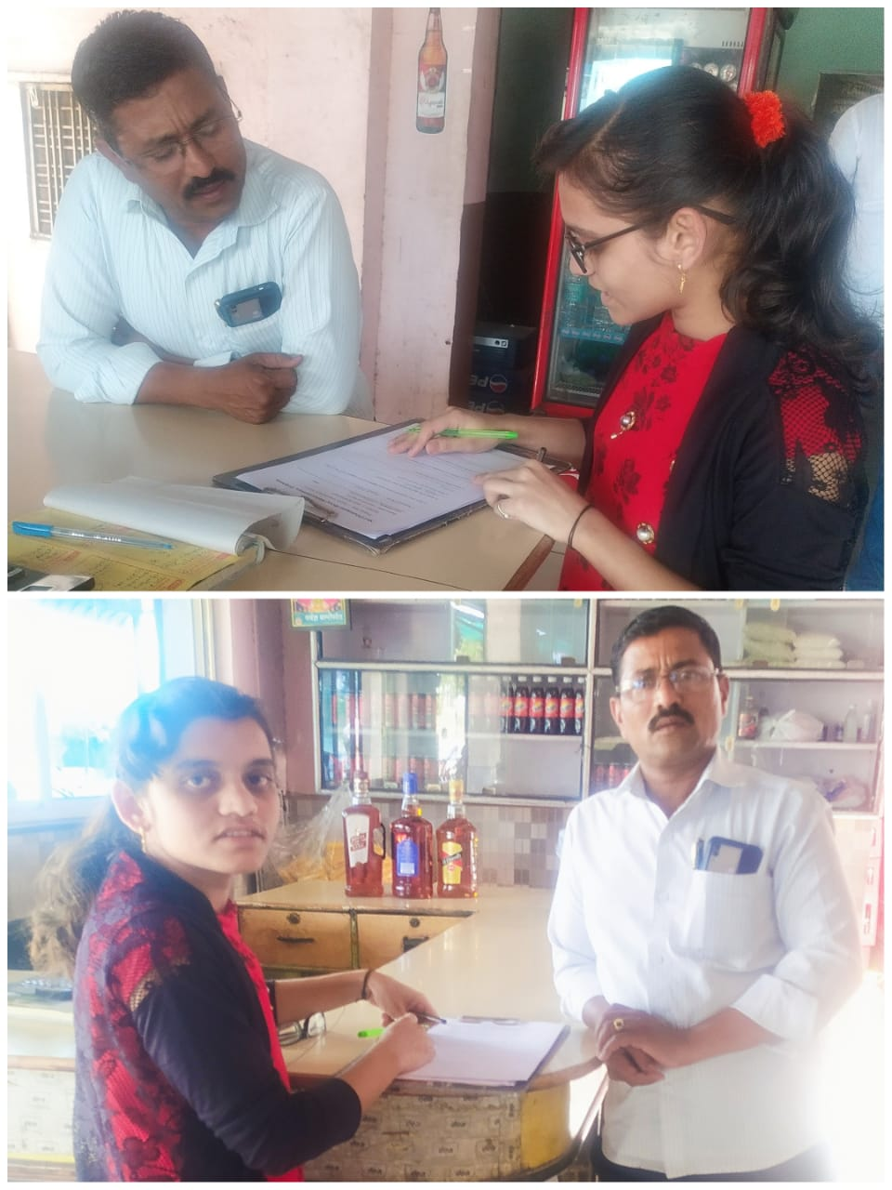1. Suyog Dhaba –

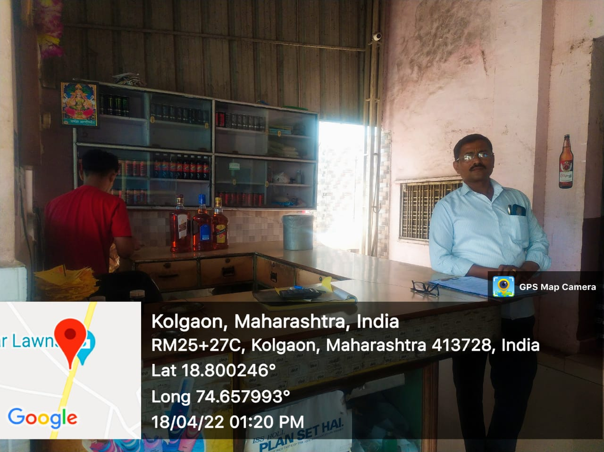

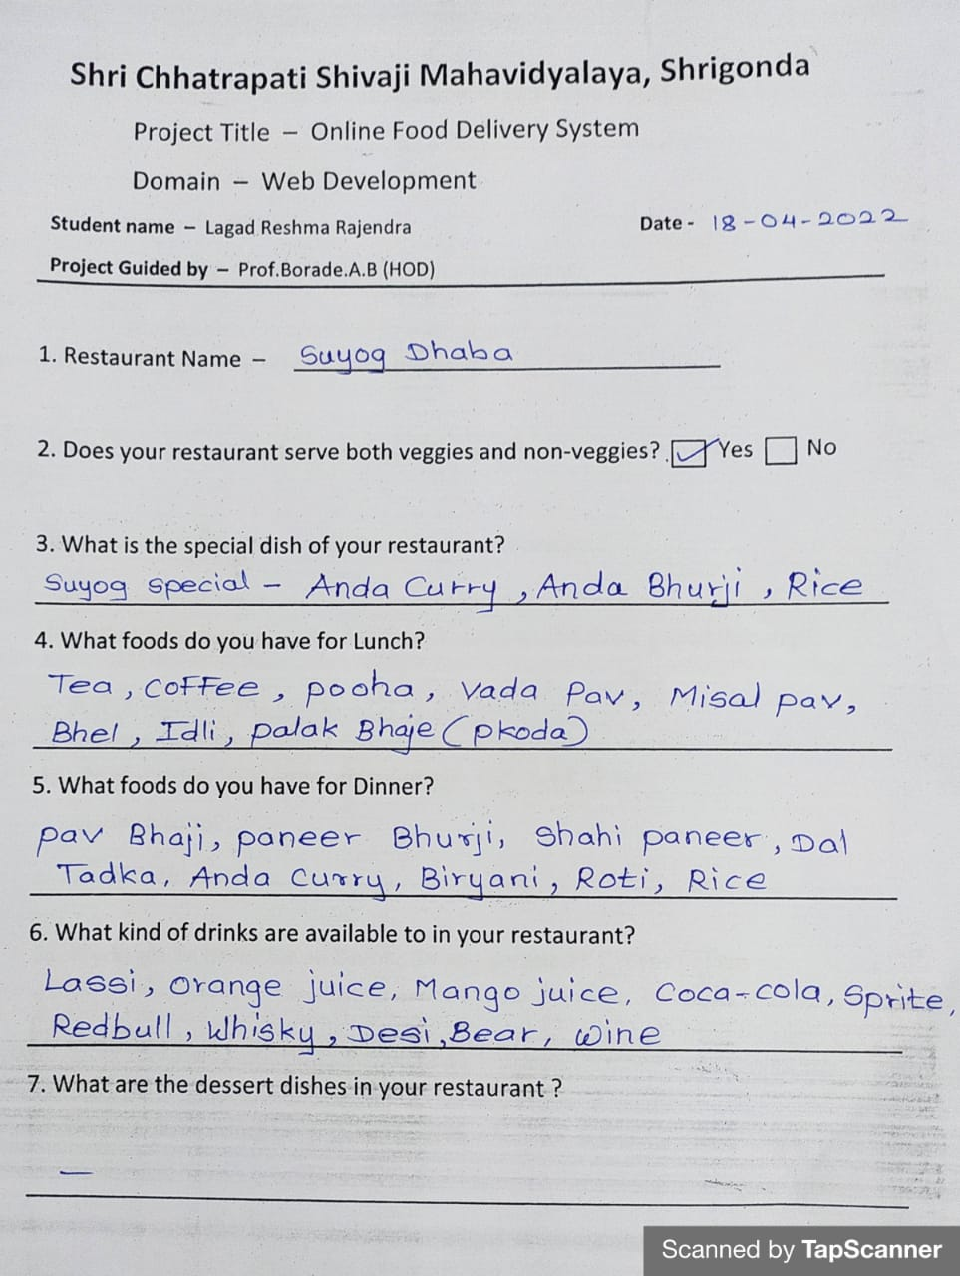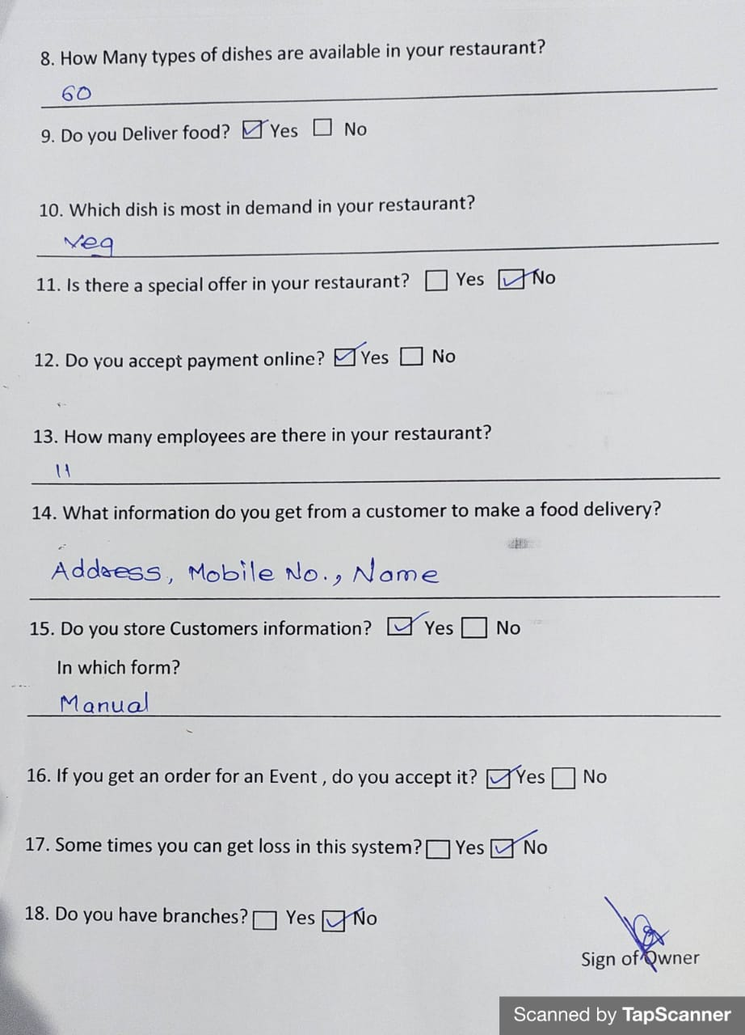

2. Rajnandini Hotel – 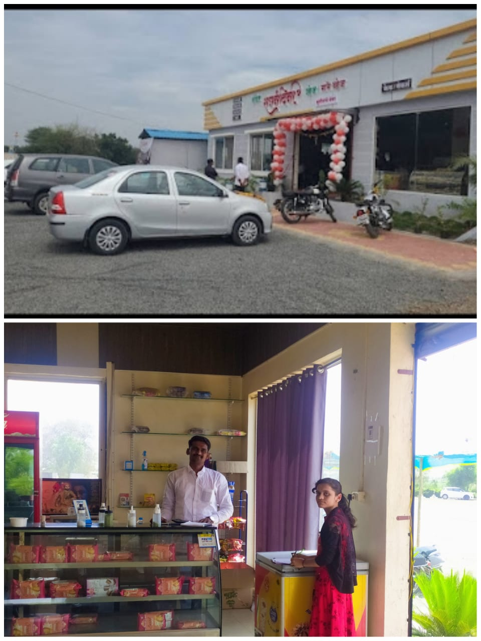

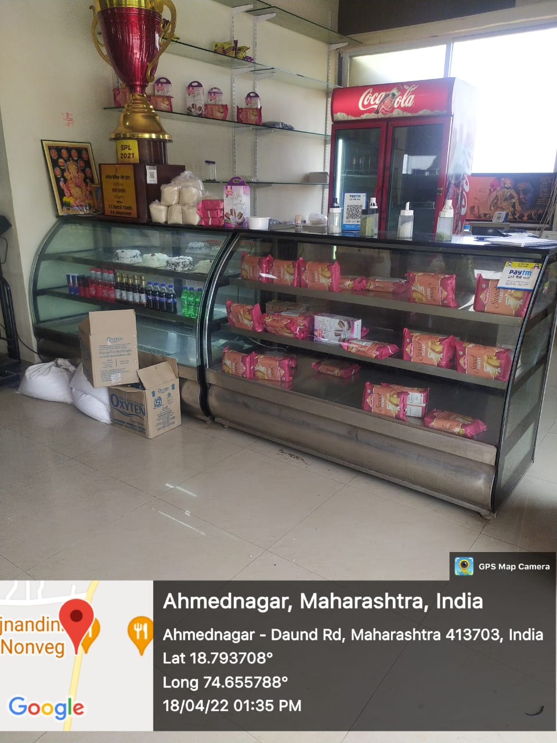

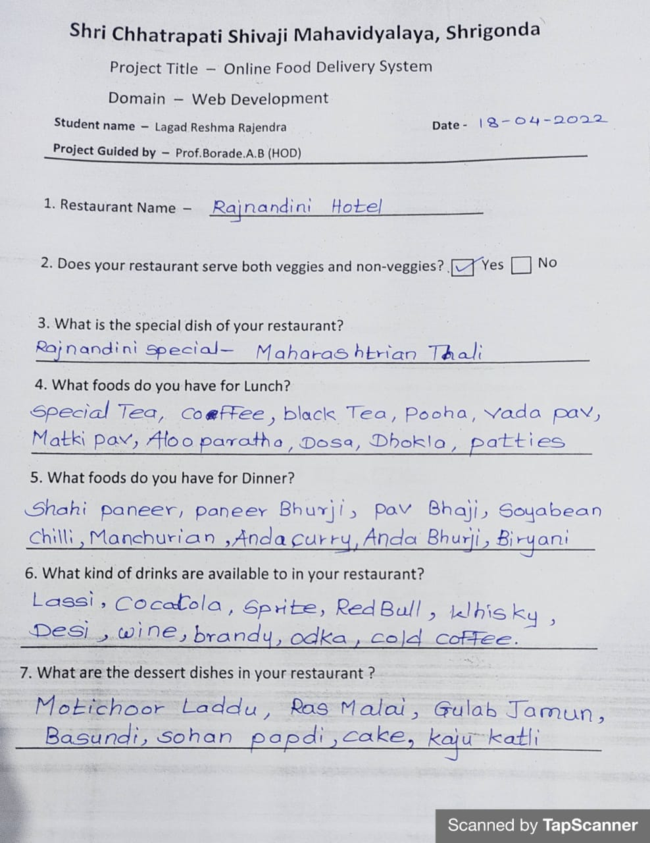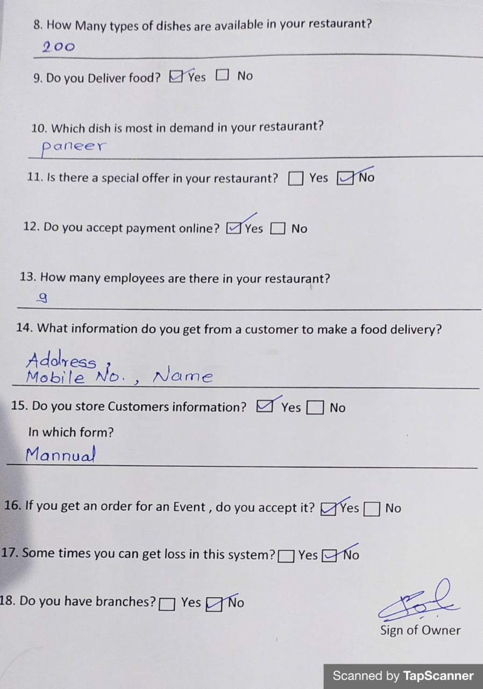

3. Wishvaratna Hotel -

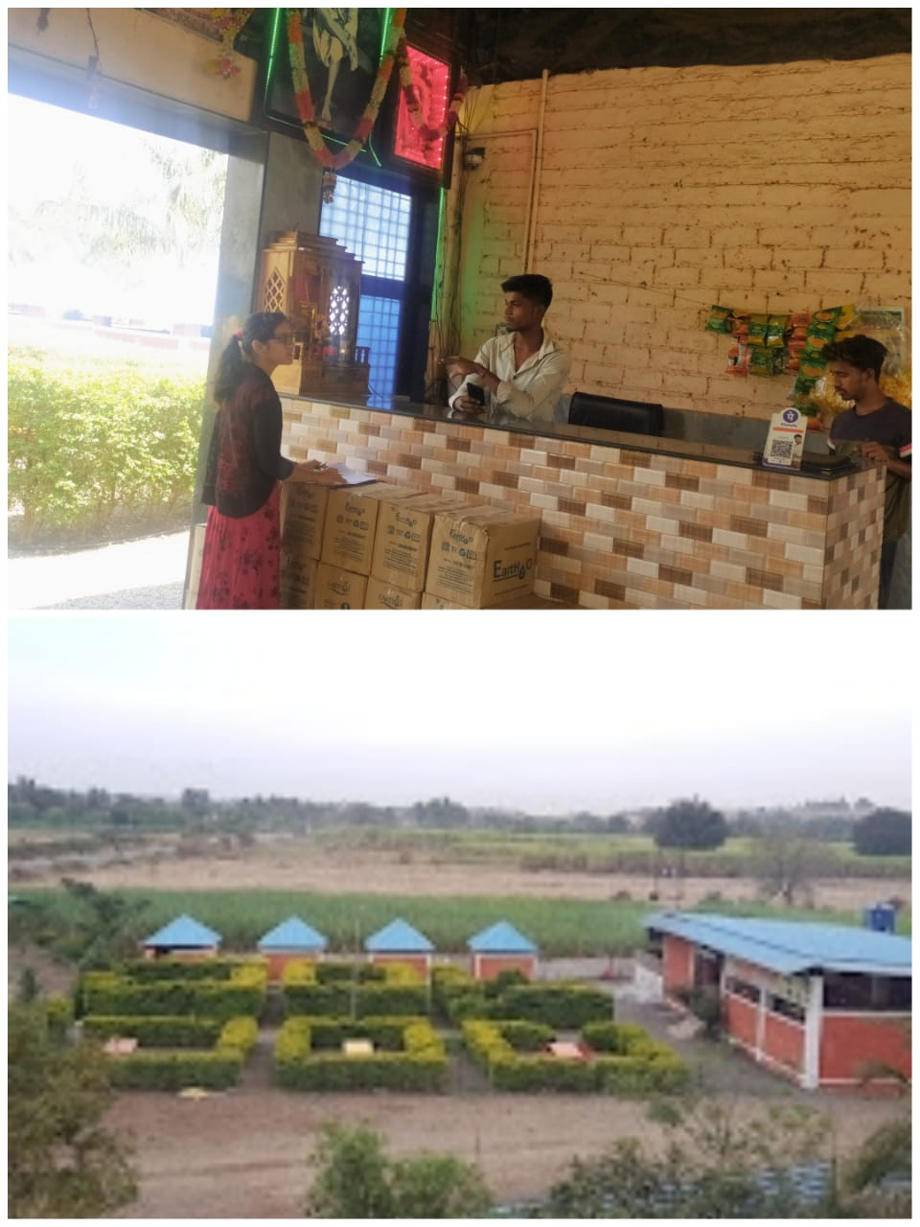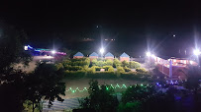

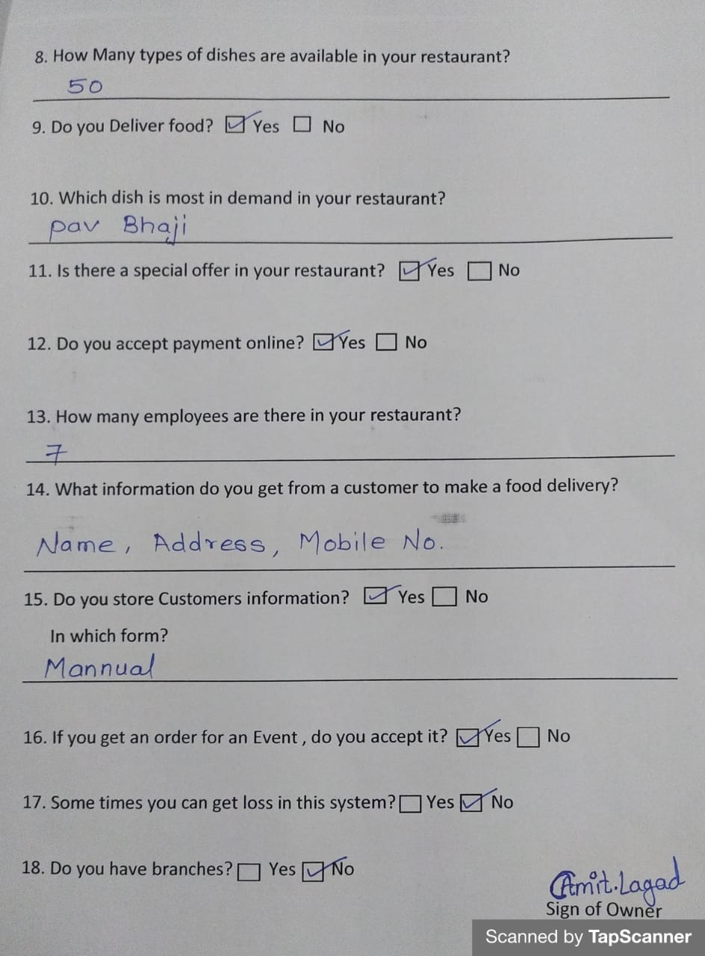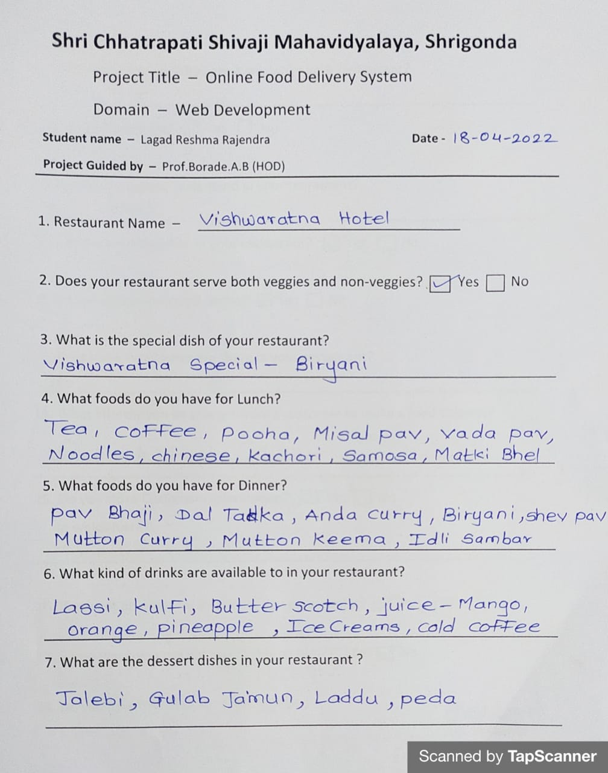

**E. SCOPE**

1. It can be used for maintaining the details of Products, Customers

etc.

1. This system use the computers or mobile for it’s all the operations

i.e. for Customers information storage, to take Order from

Customer, Automatic bills etc.

1. By using this application, all working is Faster and Accurate.
2. The data can be retrieved easily. The data are well protected for

personal use And the data processing is very fast.

1. Also, as it is the online website. So it can be accessible from

anywhere by using Internet.

**F. LIMITATIONS**

1. Chances of hacking Customers information.

2. Area Limited for Delivery

**2. SYSTEM ANALYSIS**

**EXITSTING SYSTEM**

1. In the present scenario, people have to physically visit the Hotels

or Restaurants for eating food and have to make payments through cash mode most of the time due to unawareness of advanced technologies at certain places.

1. In this method time as well as physical work is required and most of the time peoples has no enough time.
2. The traditional food ordering procedure is not efficient enough for

hotels and restaurants , as they have to deal with the crowd, in their restaurant.

1. In existing system, all collected data are stored on paper as well as

in register format manually.

1. For paper based work, the waiter comes and write down foods

that customers order and pass the food list containing paper to the chefs or cooks in the kitchen for future process.

1. Also, from the owner’s point of view maintaining data records and

the accounts in the register file are hard and annoying work to do.

and also, it is full of risk as anyone can access it and modify the

data.

1. **SCOPE AND LIMITATIONS OF EXISTING SYSTEM**
2. Not User Friendly – The existing system is not user friendly because the retrieval of data is very slow and data is not maintained efficiently.
3. Difficulty in Report generating.
4. All Calculations to generate report is manually so there is greater chance of errors.
5. Lots of Paperwork.
6. Loss of even a single register/recorded to difficult situation Because all the papers are needed to generate the reports.
7. Time Consuming.
8. **PROJECT PERSPECTIVE AND FEATURES**

* **PROJECT PERSPECTIVE –**

1. To Computerized the Food Ordering System Process and display Details of sales history.
2. The data can be retrieved easily. The interface is very user-friendly.
3. The data are well protected for personal use and the data processing is very fast.

* **FEATURES (PURPOSED SYSTEM) –**

1. User Friendly – the user interface of the project is very simple.
2. Order reports of the system can be easily generated. In this way they can get delivery status of customers and get information about what is being ordered.
3. Very Less Paper Work – Online Food Ordering System requires less paper work. In this project all record is fetched directly into the computer and reports can be generated through just a click. In this way it saves time. As data is directly entered into database. So there is no need to do any paper work.
4. Data feeding and retrieving in this system is very easy. So the work can be done on time.



1. **STAKEHOLDER****S**

customers

Admin

Delivery Boys

Restaurants

**1. Customers –**

The Customer performs following tasks

* Registration
* Login
* Choose City
* Choose near Restaurant
* Add Dishes in our Cart
* After adding dishes click on Cart button and decide dish Quantity.
* For paying bill , just click on Add to Cart button and choose payment mode.
* Also, gives Feedback

**2. Admin**

The Admin performs following tasks

* Login
* Manage and Add Cities
* Manage and Add Restaurants
* Manage and Add Dishes
* Manage and Add Delivery Boys
* Manage Order – Pending, Cancelled, Complete, All
* Assigns order to delivery boys

**3. Delivery Boys**

The Delivery Boy performs following tasks

* Accept Order
* Deliver Food
* Take Payment

**4. Restaurants**

The Restaurants performs following tasks

* Add Dishes in our restaurants
* Manage customers order
* Make Food according to customers order
* Try to work on customers feedback

**E. REQUIREMENT ANALYSIS**

1. FUNCTIONAL REQUIREMENTS –

* Order Management
* Reporting Management
* Menu Management
* Billing Management
* Goods and Services Tax Management
* Order Queue Module

1. PERFORMANCE REQUIREMENTS –

* The system should let user to place an order in a short period of

time.

* The system should complete perform the billing process in a short

period of time.

1. SECURITY REQUIREMENTS –

* The System should validate the username and password in order to login and make changes to the system.
* The system should request the current password of the user in order to let them change to a new password.

**3. SYSTEM DESIGN**

**A. USING AN OOSE**

**1. ER Diagram**

**M 1**

Deliver

needss

Login

Delivery Boy

Customer

**1 1 1 M**

gives

gives

assigns

choose

Payment

**M M**

Order

to

**M**

Dishes

**M**

to

have

add

**1 1**

Admin

**1 1 1**

add

**M**

Restaurants

**M**

needs

have

add

**1 M**

Login

Cities

**2. Class Diagram**

|  |
| --- |
| Admin |
| Username  Password |
| Add()  Modify()  View() |

|  |
| --- |
| Customer |
| Customer_id  Customer_name  Customer_address  Customer_mobile |
| Add()  Modify()  View() |

1

1 M

|  |
| --- |
| Order |
| Order_id  Dish_id  Dish_name  Dish_quantity |
| Add()  Modify()  View() |

|  |
| --- |
| Login |
| Username  Password |
| View() |

1

|  |
| --- |
| Dishes |
| Dish_id  Dish_name  Category  Price |
| Add()  Modify()  View() |

|  |
| --- |
| Payment |
| Payment_id  Payment_date  Bank_name  Total_price  Order_id |
| Add()  Modify()  View() |

M M 1

**3. Object Oriented Diagram**

|  |
| --- |
| C: Cities |
| City_id  City_name  Pincode  Restro_names  City_image  Added_on |

|  |
| --- |
| R: Restaurants |
| Restro_id  City_name  Contact  Address  Image  Added_on |

|  |
| --- |
| D: Dishes |
| Dish_id  Dish_name  Category  Price  Image  Added_on |

|  |
| --- |
| O: Order Details |
| Order_id  Dish_id  Quantity  Price  Total_price |

|  |
| --- |
| D: Delivery Details |
| Order_id  Customer_id  Total_price  Status |

|  |
| --- |
| C: Cart Details |
| Cart_id  Cart_date  Cart_mode  Bank_name  Order_id  Total_price |

**4. Use Case Diagram**

**Admin**

**Customer**

**Restaurant Employee**

**5. Sequence Diagram**

Customer

Delivery Boy

Admin

System

1. Registration



2. Login

3. Add Restaurants

4. Add Dishes

5. Show Restraurant

6. Show Dishes

7. Order Food

8. Bill

9. Payment 10. Assigns Address

11. Check Status

12. Deliver Order

13. Receive Order

14. Give Feedback

**6. Activity Diagram**

|  |  |  |
| --- | --- | --- |
| **Customer** | **Online Food Ordering System** | **Restaurant Orders** |
| Request  Choose From Menu  Start  Order Confirm  Pay the Bill  Receives Order  Enter Quantity | Display Payment  End  Ask for how many orders?  Display Orders  Confirmation if menu is available  Display Menu Details  Show Menu | Receives Payment  Prepare the order  Menu is available |

**7. State Chart Diagram**

Start

Online Food Ordering System

No

Login

User

Admin

Yes No

Show items

Reg

Login

Item View Add Cart

Item Manage

Yes

Place Order

Manage Order

Order Cancel

Payment Manage

Manage User

Payment

Logout

End

**8. Component Diagram**

Login

Open Website

index.php

Search Restaurant

Logout

logout.php

Payment

Order Food

**9. Deployment Diagram**

Open Website

Receive Food

Login

Check Status

Search Food

Payment

Place Order

**B. USING DATA MODEL**

**ADMIN LOGIN TABLE**

|  |  |  |  |
| --- | --- | --- | --- |
| Field Name | Data Type | Constraint | Description |
| id | Int (auto) | Primary Key | id |
| name | Varchar(255) |  | name |
| username | Varchar(255) |  | username |
| password | Varchar(255) |  | password |
| email | Varchar(255) |  | email id |

**CUSTOMERS TABLE**

|  |  |  |  |
| --- | --- | --- | --- |
| Field Name | Data Type | Constraint | Description |
| id | Int(auto) | Primary Key | Id |
| username | Varchar(255) | - | Username |
| first_name | Varchar(255) | - | First name |
| last_name | Varchar(255) | - | Last name |
| email | Varchar(255) | unique | Email Id |
| contact | Varchar(255) | unique | Mobile No. |
| password | Varchar(255) | - | Password |
| address | Varchar(255) | - | Address |
| added_on | date | current date | Registration Date |

**CUSTOMERS FEEDBACK TABLE**

|  |  |  |  |
| --- | --- | --- | --- |
| Field Name | Data Type | Constraint | Description |
| id | Int(auto) | Primary Key | Id |
| username | Varchar(255) | - | Customer name |
| rate | Float | - | Star rating points |
| opinion | Varchar(255) | - | Opinion |
| profile_image | Varchar(255) | - | Customer profile pic. |

**ADD CITIES TABLE**

|  |  |  |  |
| --- | --- | --- | --- |
| Field Name | Data Type | Constraint | Description |
| id | Int(auto) | Primary Key | Id |
| city_name | Varchar(255) | - | City name |
| pincode | Varchar(255) | - | City pincode |
| restro_names | Varchar(255) | - | Restaurant name |
| city_image | Varchar(255) | - | City image |
| added_on | date | Current date | Date |

**ADD RESTAURANTS TABLE**

|  |  |  |  |
| --- | --- | --- | --- |
| Field Name | Data Type | Constraint | Description |
| id | Int(auto) | Primary Key | Id |
| restro | Varchar(255) | - | Restaurant name |
| city | Varchar(255) | - | City name |
| email | Varchar(255) | - | Email id |
| contact | Varchar(255) | - | Mobile No. |
| website | Varchar(255) | - | Restaurant website |
| open | Varchar(255) | - | Opening time |
| close | Varchar(255) | - | Closing time |
| days | Varchar(255) | - | Open days |
| address | Varchar(255) | - | Restaurant address |
| image | Varchar(255) | - | Restaurant image |
| added_on | date | Current date | Added date |

**ADD DISHES TABLE**

|  |  |  |  |
| --- | --- | --- | --- |
| Field Name | Data Type | Constraint | Description |
| id | Int(auto) | Primary Key | Id |
| dish_name | Varchar(255) | - | Dish name |
| category | Varchar(255) | - | Dish category |
| rate | Float | - | Dish star rate |
| price | Int | - | Dish price |
| dish_image | Varchar(255) | - | Dish image |
| added_on | date | Current date | Added date |

**ADD DELIVERY BOYS**

|  |  |  |  |
| --- | --- | --- | --- |
| Field Name | Data Type | Constraint | Description |
| id | Int(auto) | Primary Key | Id |
| name | Varchar(255) | - | D boy name |
| contact | Varchar(255) | - | Mobile No. |
| password | Varchar(255) | - | password |
| address | Varchar(255) | - | D boy address |
| added_on | date | Current date | D boy added date |

**ORDER DETAILS TABLE**

|  |  |  |  |
| --- | --- | --- | --- |
| Field Name | Data Type | Constraint | Description |
| order_id | Int(auto) | Primary Key | Order id |
| dish_id | Int | Foreign Key | Dish id |
| quantity | Int | - | Dish quantity |
| price | Int | - | Dish price |
| total_price | Int | - | Total price |

**ORDER MASTER TABLE**

|  |  |  |  |
| --- | --- | --- | --- |
| Field Name | Data Type | Constraint | Description |
| order_id | Int | Foreign Key | Order id |
| customer_id | Int | Foreign Key | Customer id |
| total_price | Int | - | Total price |
| status | Varchar(255) | - | Delivery status |

**CART TABLE**

|  |  |  |  |
| --- | --- | --- | --- |
| Field Name | Data Type | Constraint | Description |
| cart id | Int | Primary Key | Card number |
| customer_id | Int | Foreign Key | Customer id |
| dish_id | Int | Foreign Key | Dish id |
| date | Datetime | - | Date |
| dish_category | Varchar(255) | - | Dish category |
| dish_name | Varchar(255) | - | Dish name |
| dish_price | Int | - | Dish price |
| dish_quantity | Int | - | Dish quantity |
| total_price | Int | - | Total price |

**PAYMENT TABLE**

|  |  |  |  |
| --- | --- | --- | --- |
| Field Name | Data Type | Constraint | Description |
| payment_id | Int | Primary Key | Payment Id |
| payment_date | Datetime |  | Payment Date |
| payment_mode | Varchar(255) | - | Payment Mode |
| bank_name | Varchar(255) | - | Bank Name |
| order_id | Int | Foreign Key | Order Id |
| total_price | Int | - | Total Price |

**C. USING USER INTERFACE**

**1. Home Page**

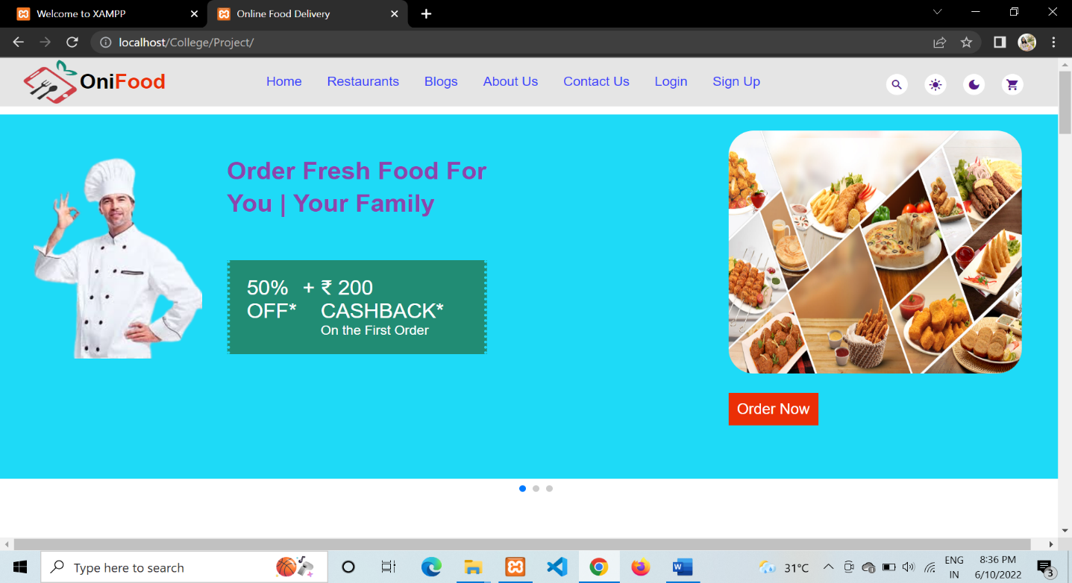

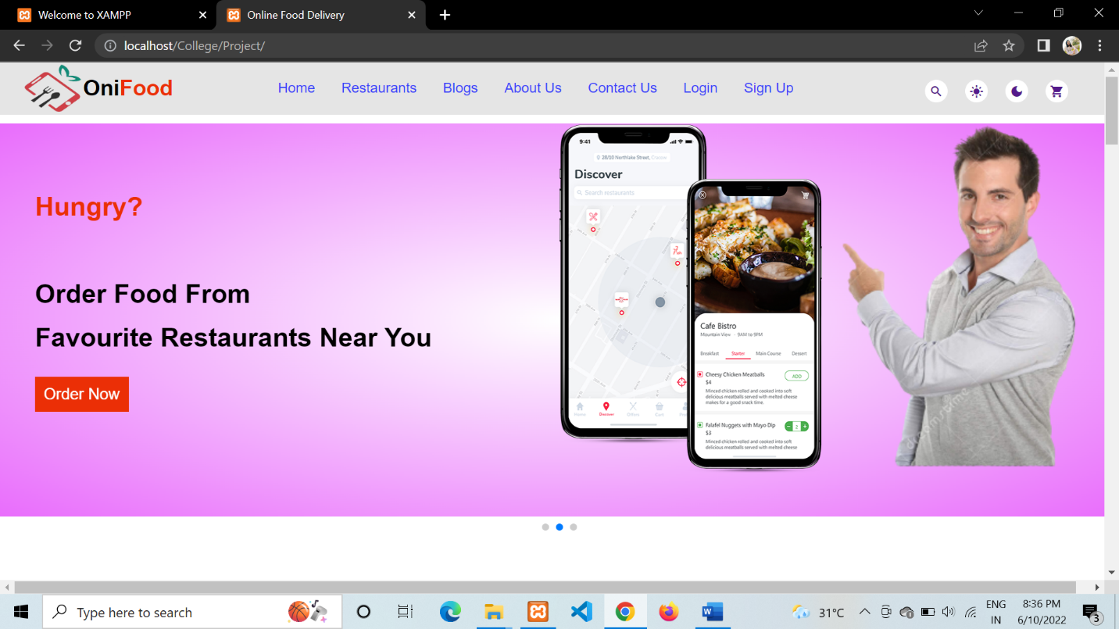

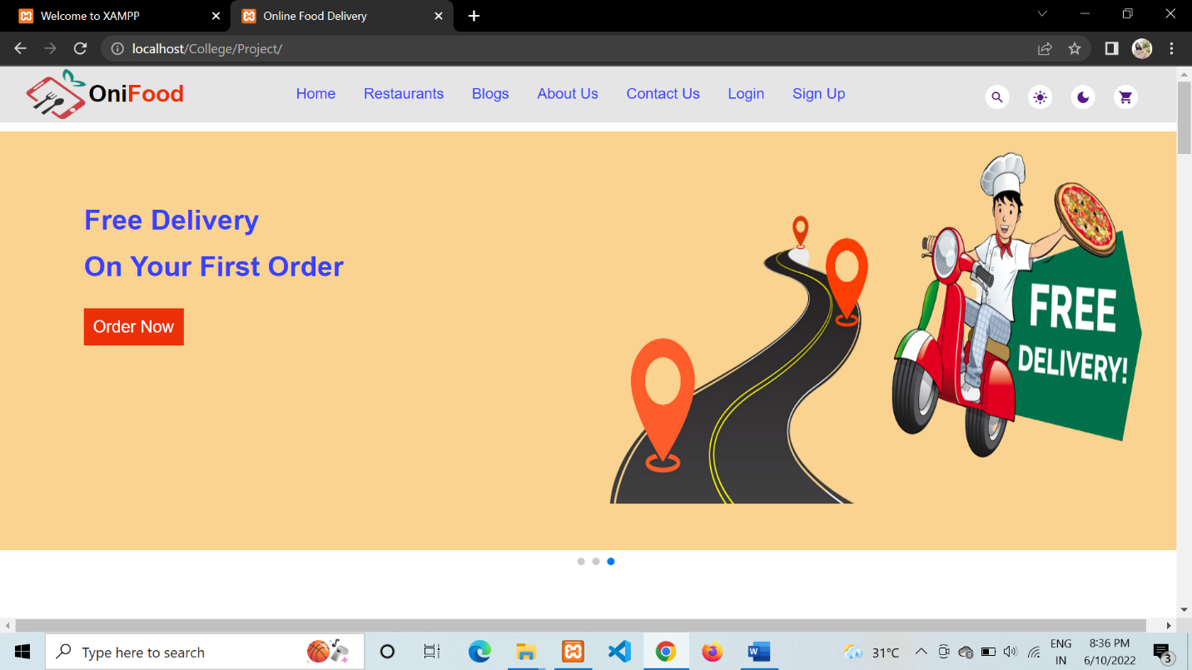

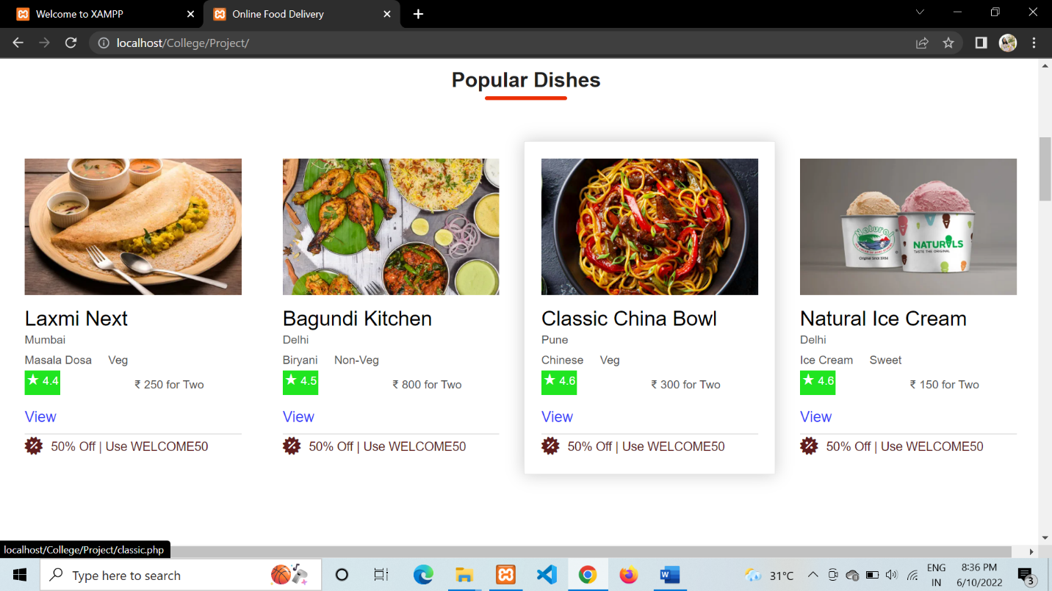

**2. User Registration Page**

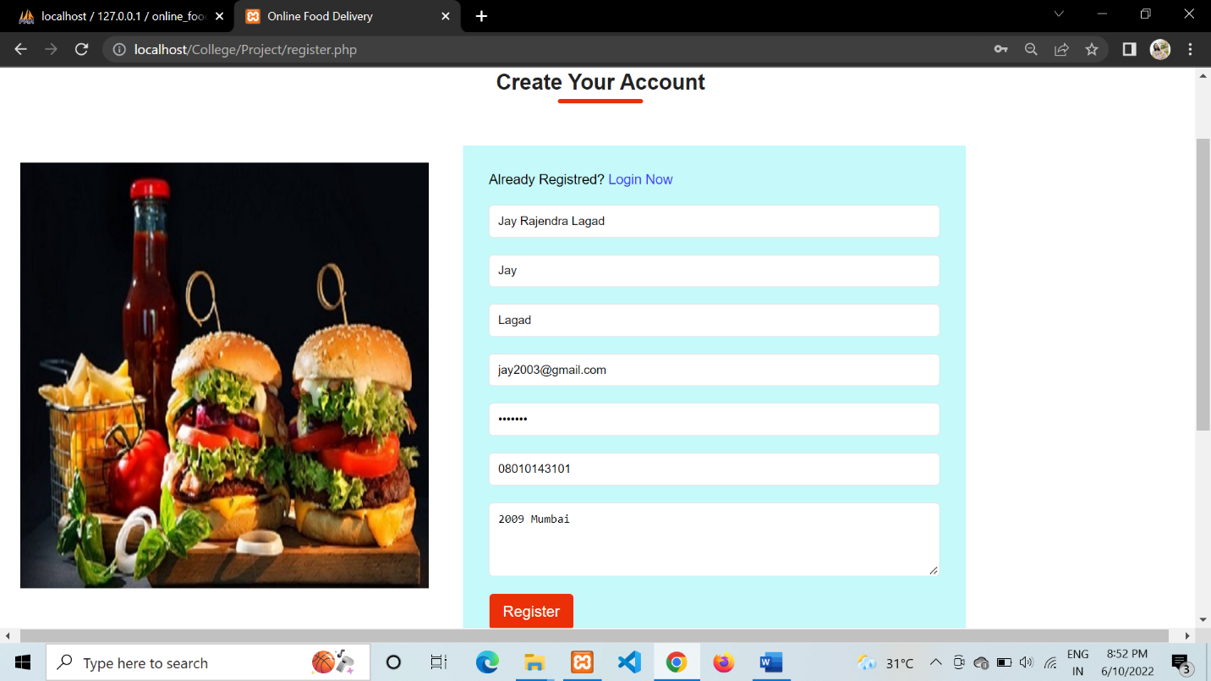

**3. User Login Page**

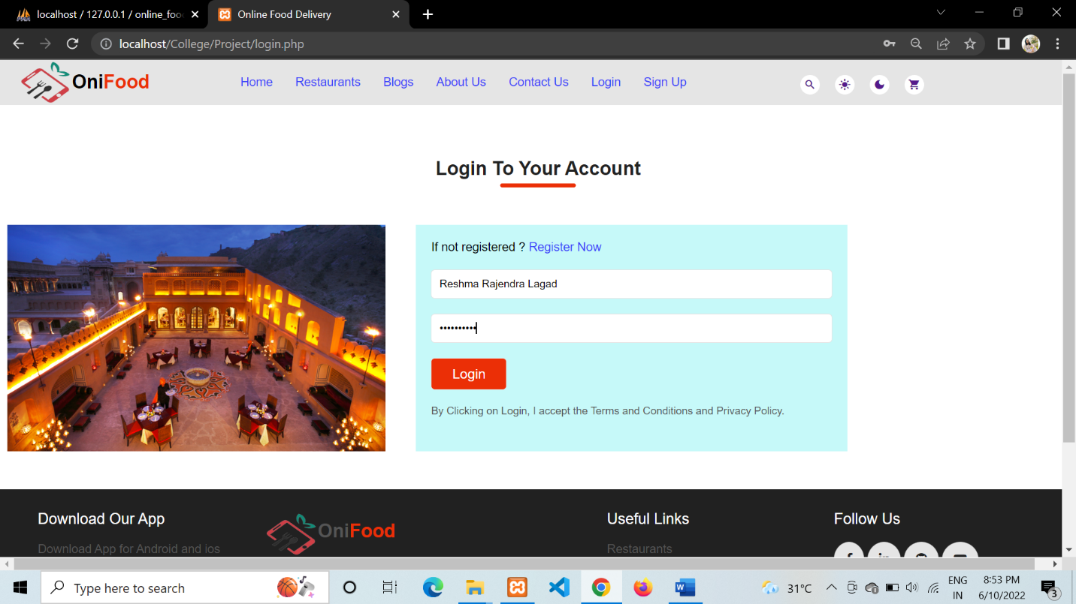

**4. Cities with Restaurants**

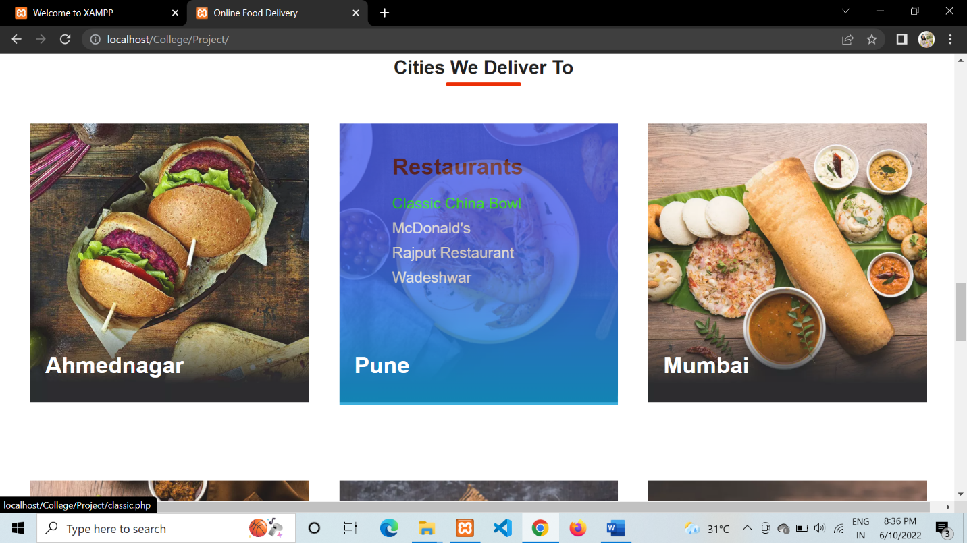

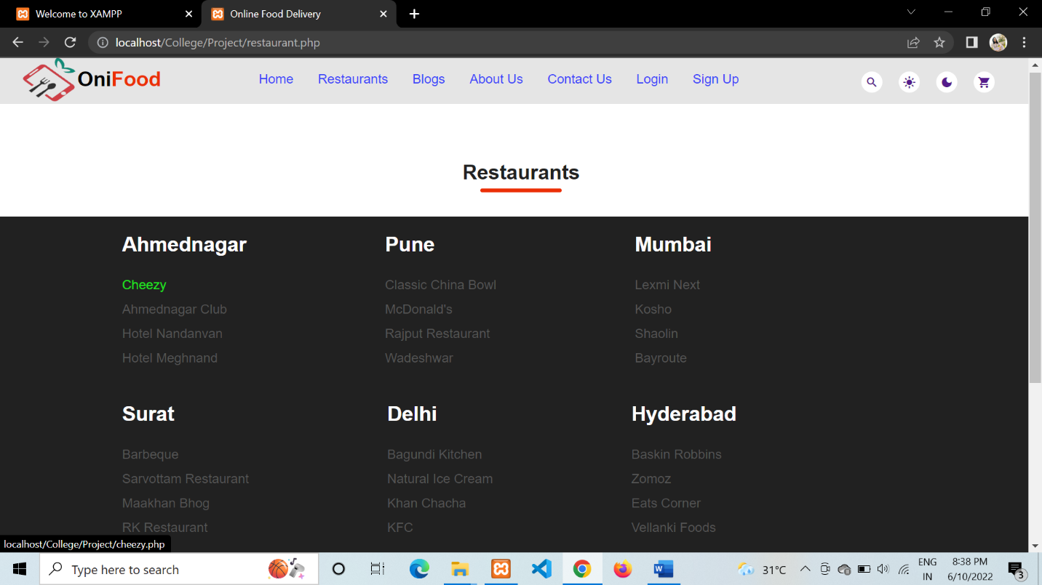

**5. Particular Restaurant Page**

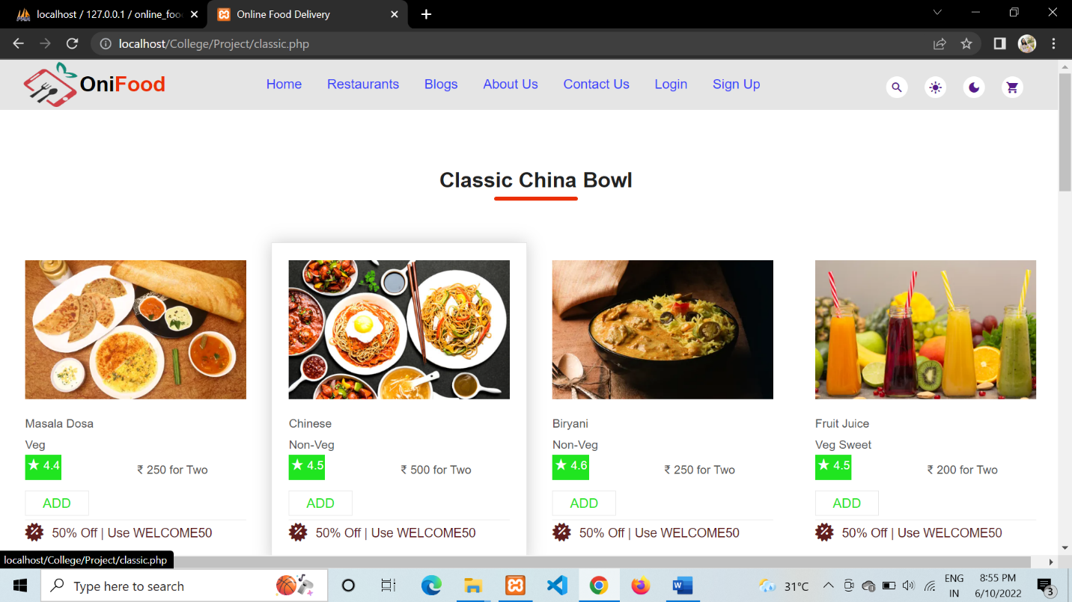

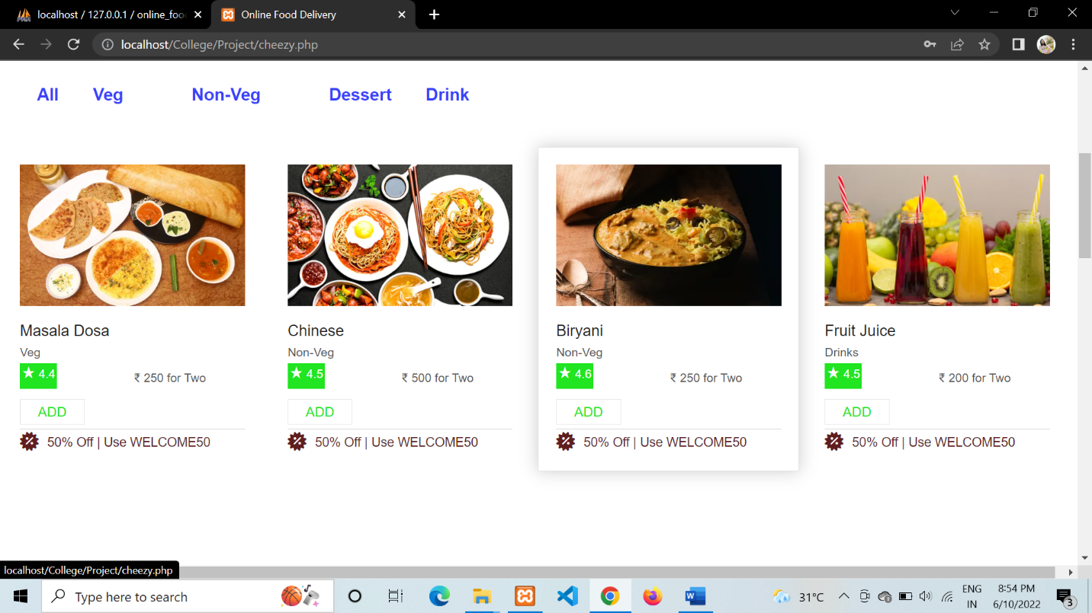

**6. About Us Page**

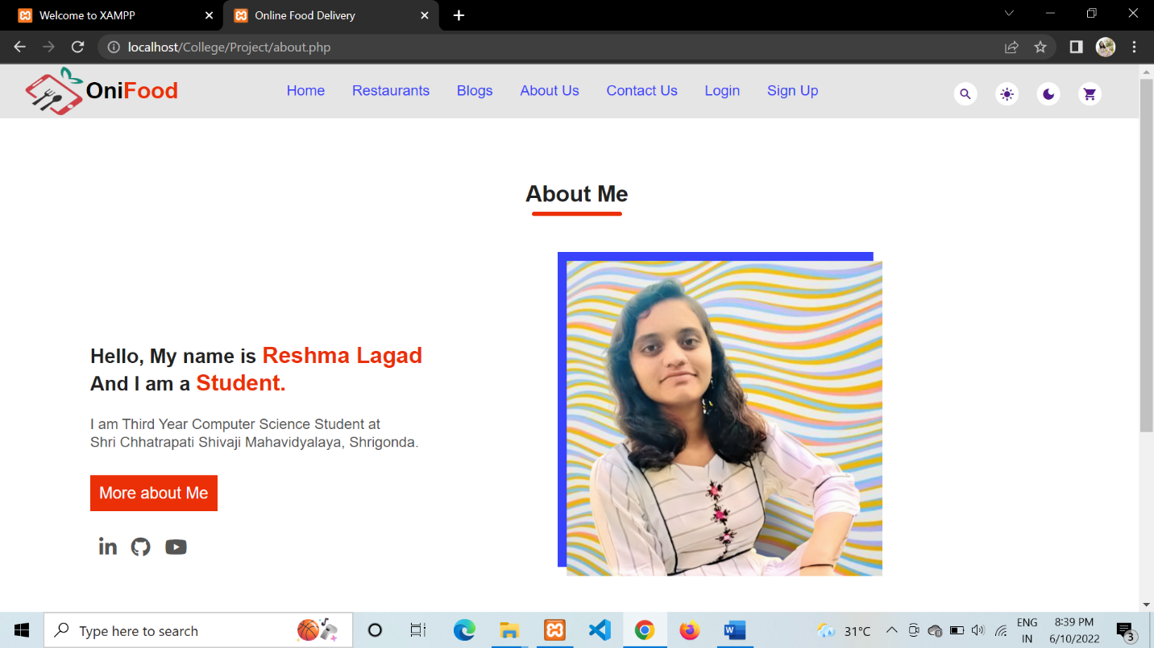

**7. Contact Us Page**

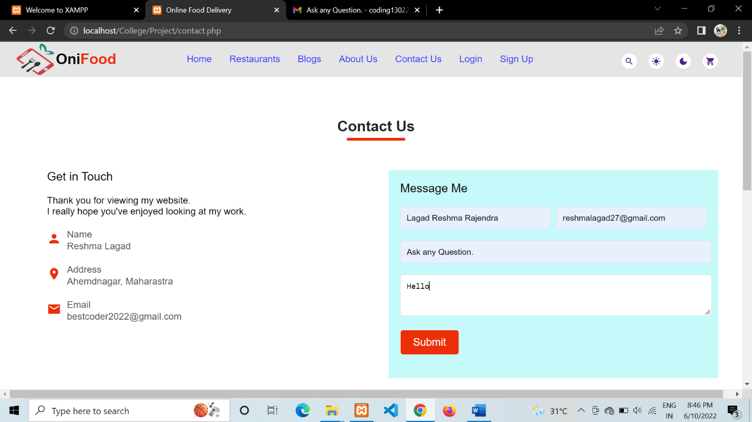

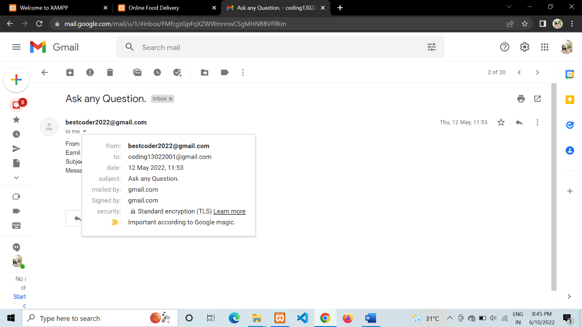

**8. Customers Feedback**

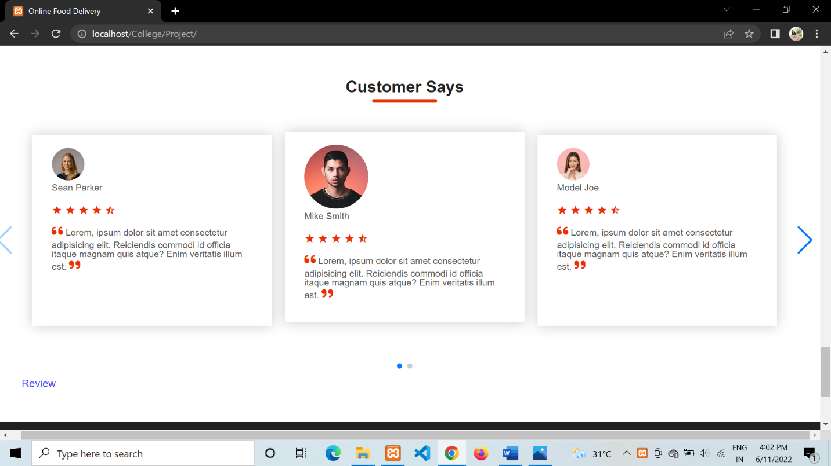

**Admin Panel**

**1. Admin Login**

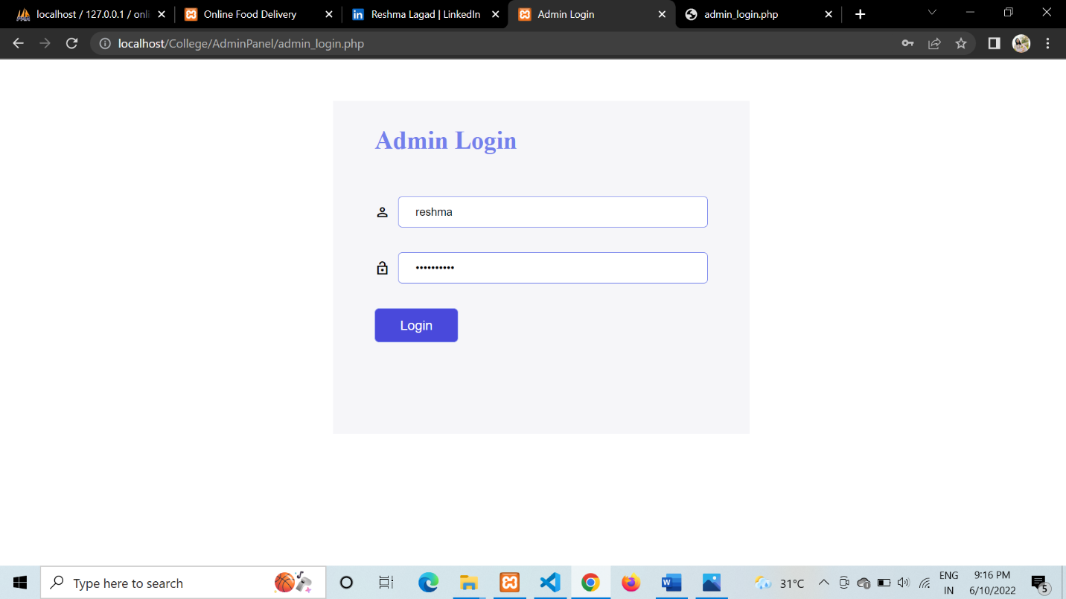

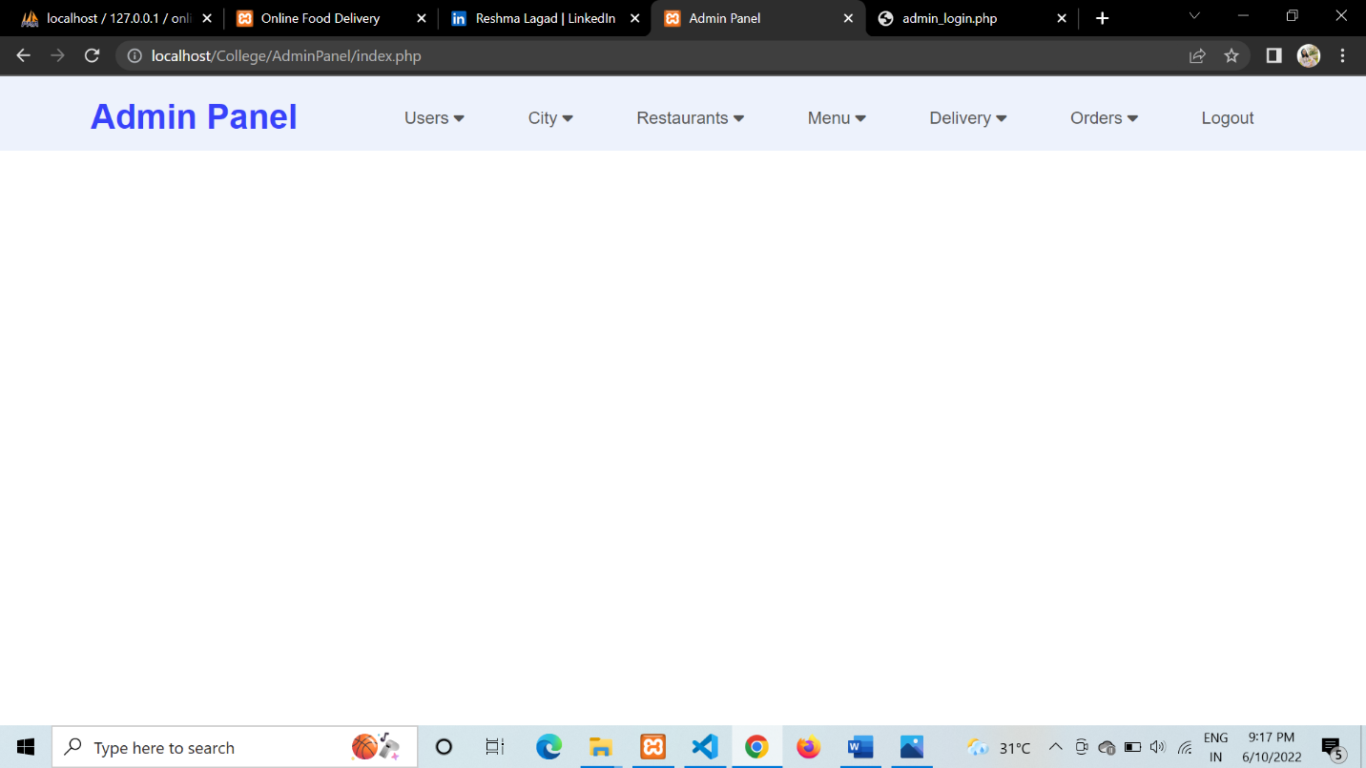

**2. Users Information**

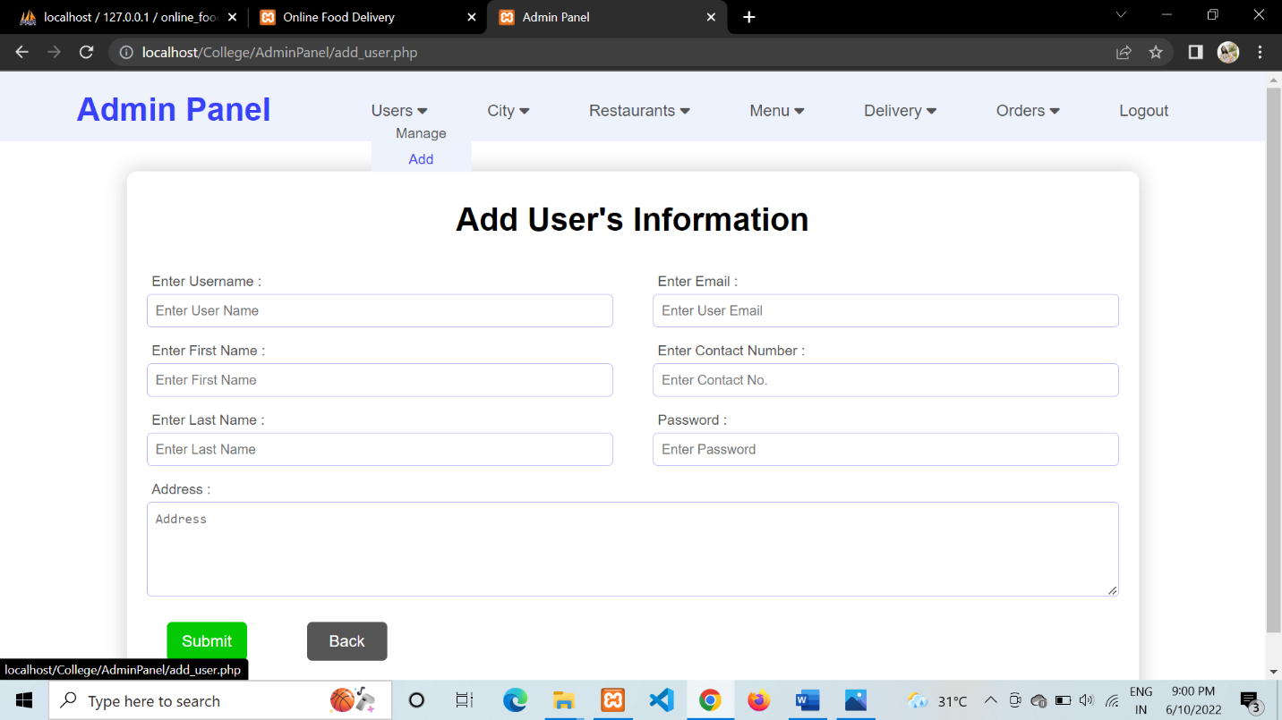

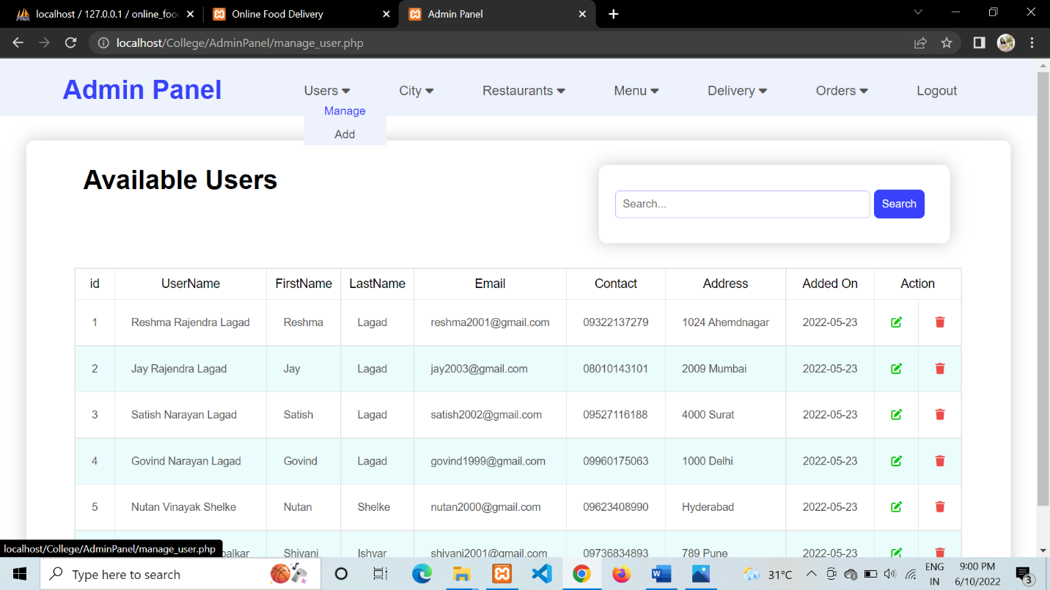

**3. Cities**

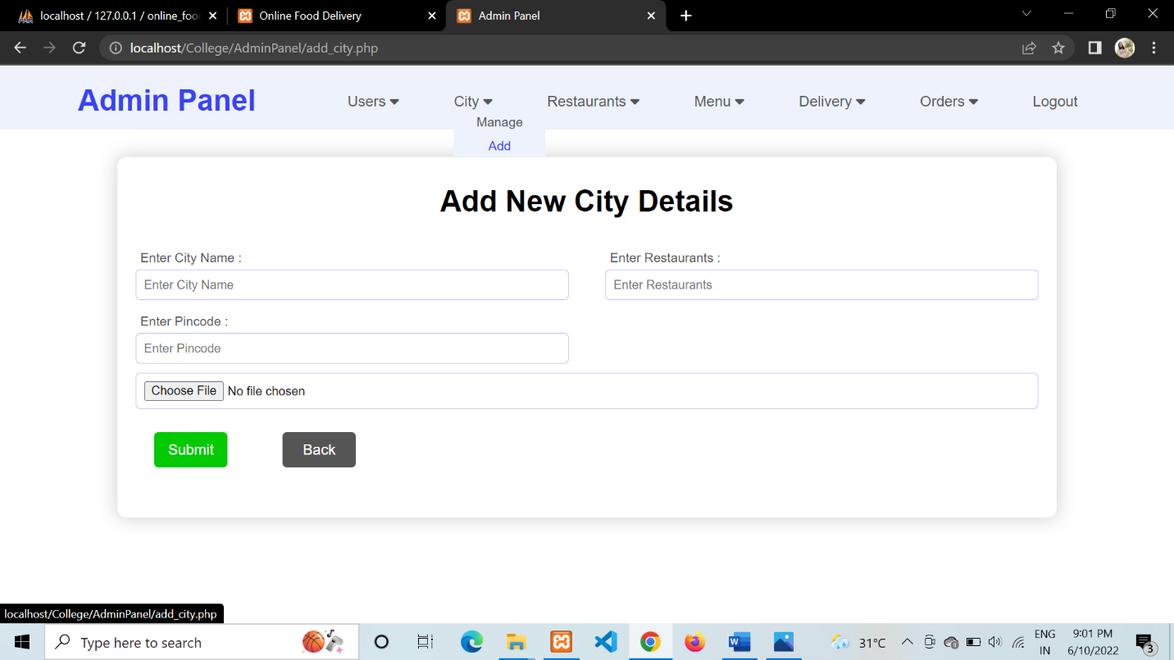

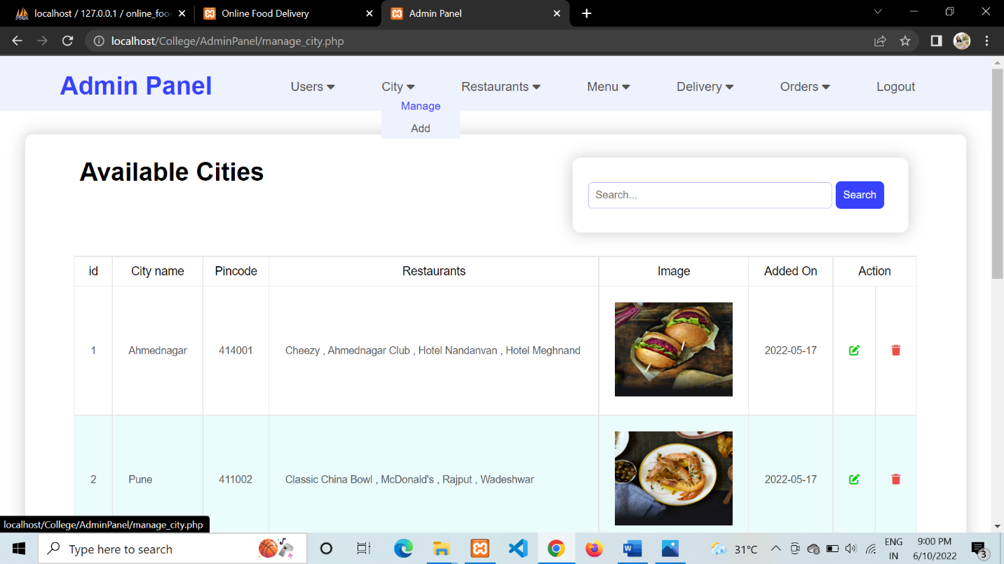

**4. Restaurants**

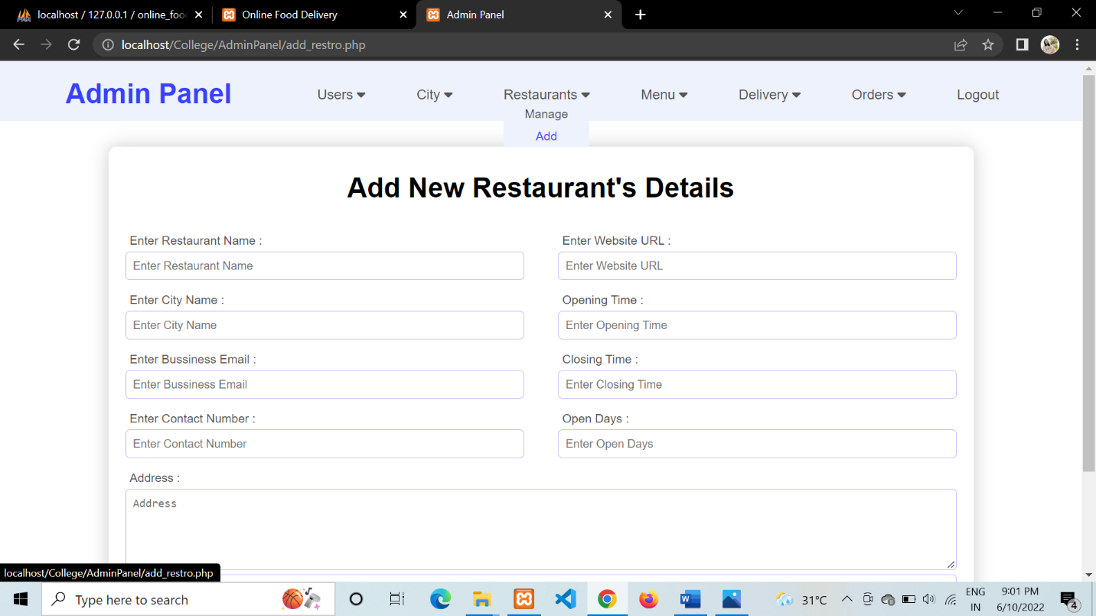

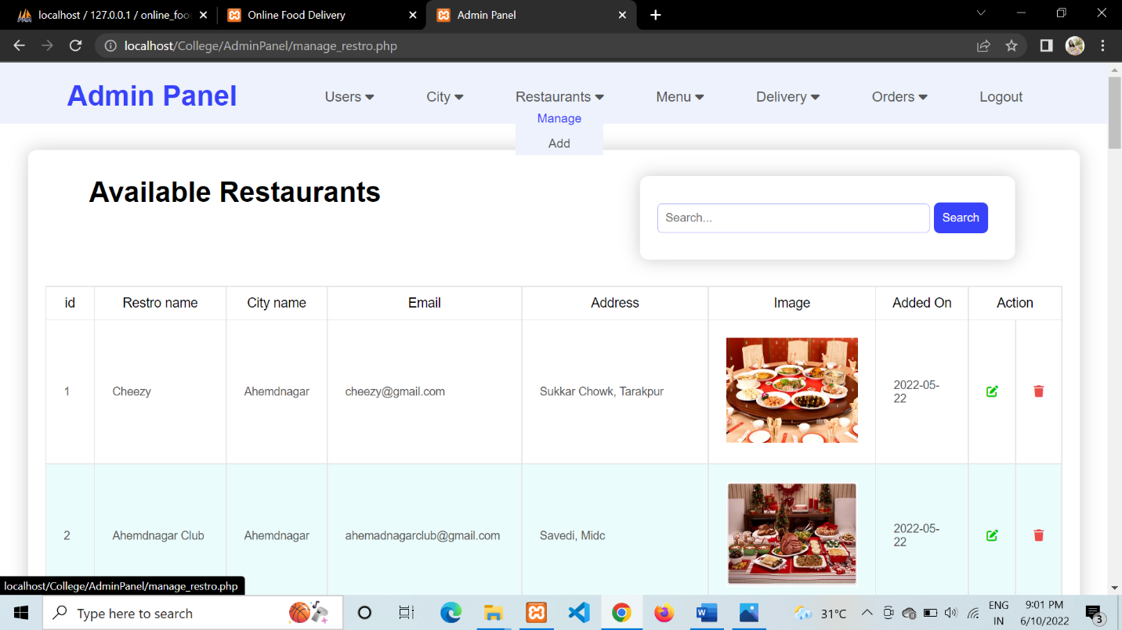

**5. Dishes**

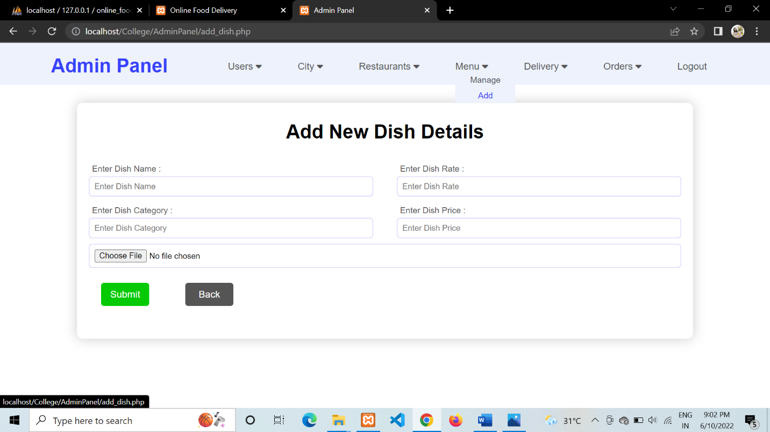

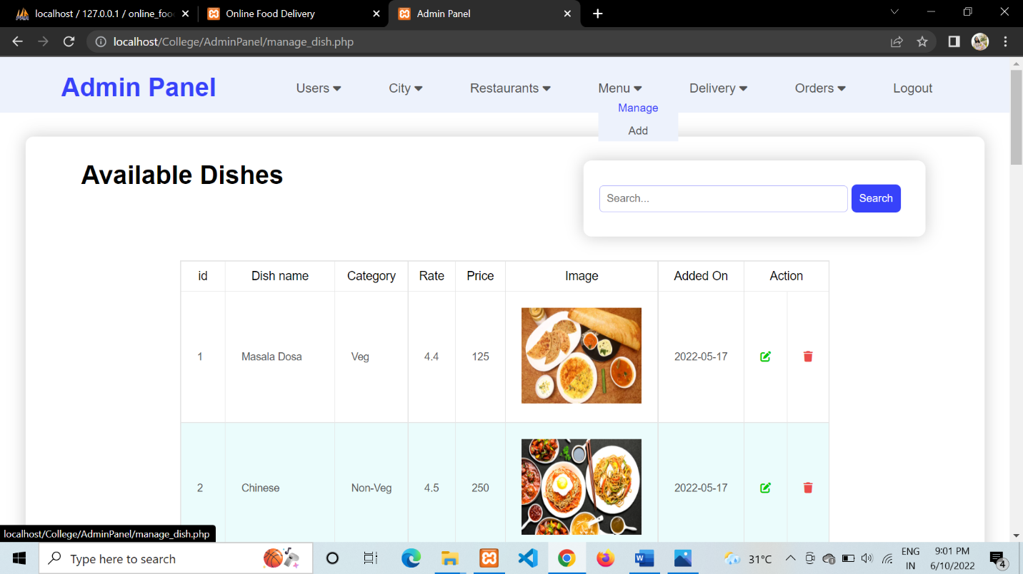

**4. IMPLEMENTATION DETAILS**

**A. SOFTWARE / HARDWARE SPECIFICATIONS**

**1. Software Specifications –**

* Operating System – Windows 10 and Ubuntu
* Front End - HTML, CSS, JAVASCRIPT
* Back End - PHP , MySQL (PhpMyAdmin)
* IDE - Visual Studio Code

**2. Hardware Specifications –**

* Processor - Pentium (min).
* Speed - 1.1 GHz (min).
* RAM - 500 MB (min).
* Hard Disk - 50 GB (min).
* I/O Devices - Mouse, Keyboard, Monitor

**5. OUTPUTS AND REPORT TESTING**

**A. BLACK BOX TESTING**

**TEST CASE - 1 ADD ACCOUNT**

|  |  |  |  |  |  |
| --- | --- | --- | --- | --- | --- |
| SL No. | Test Cases | Result1 | Result2 | Result3 | Result4 |
| 1. | Email id is unique. | True | True | False | False |
| 2. | Password is unique. | True | False | True | False |
| 3. | Final Result | Success | Fail | Fail | Fail |

1. For Valid Data

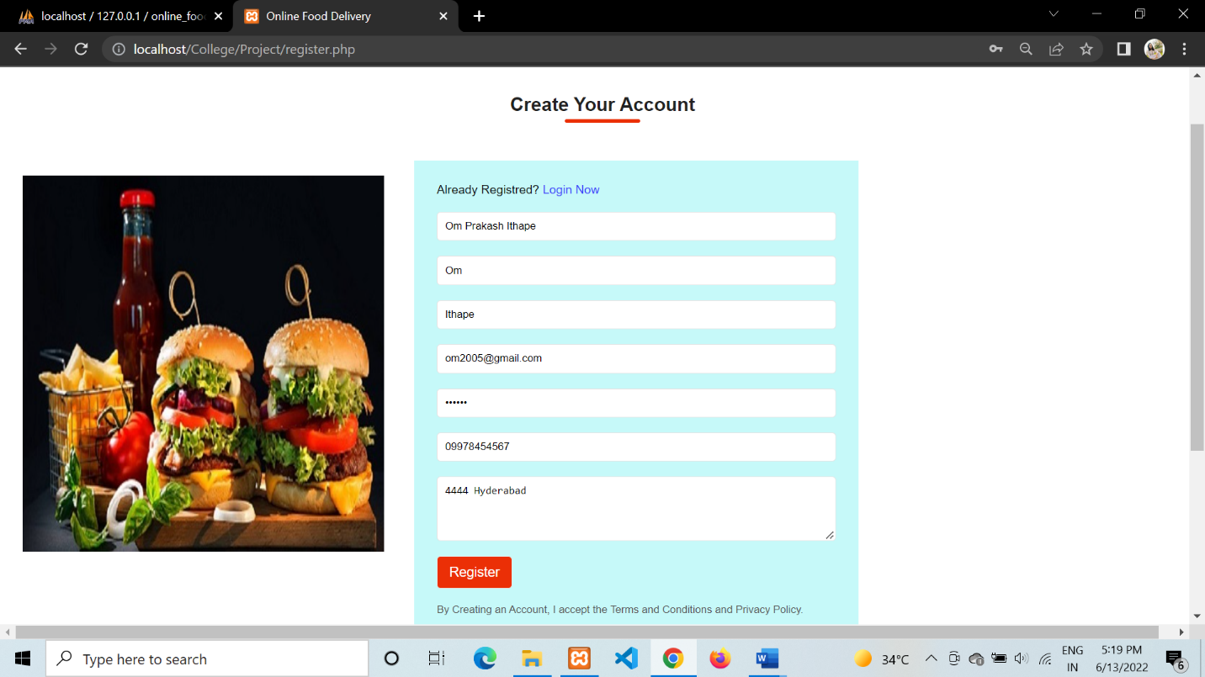

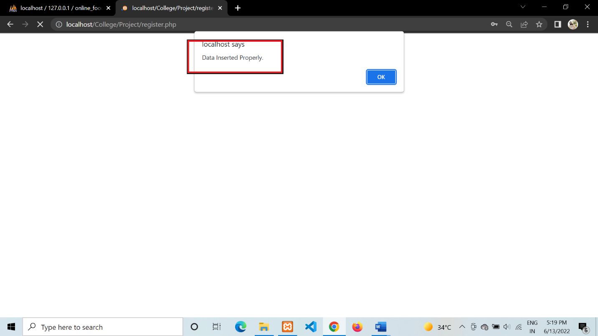

2. For Invalid Data

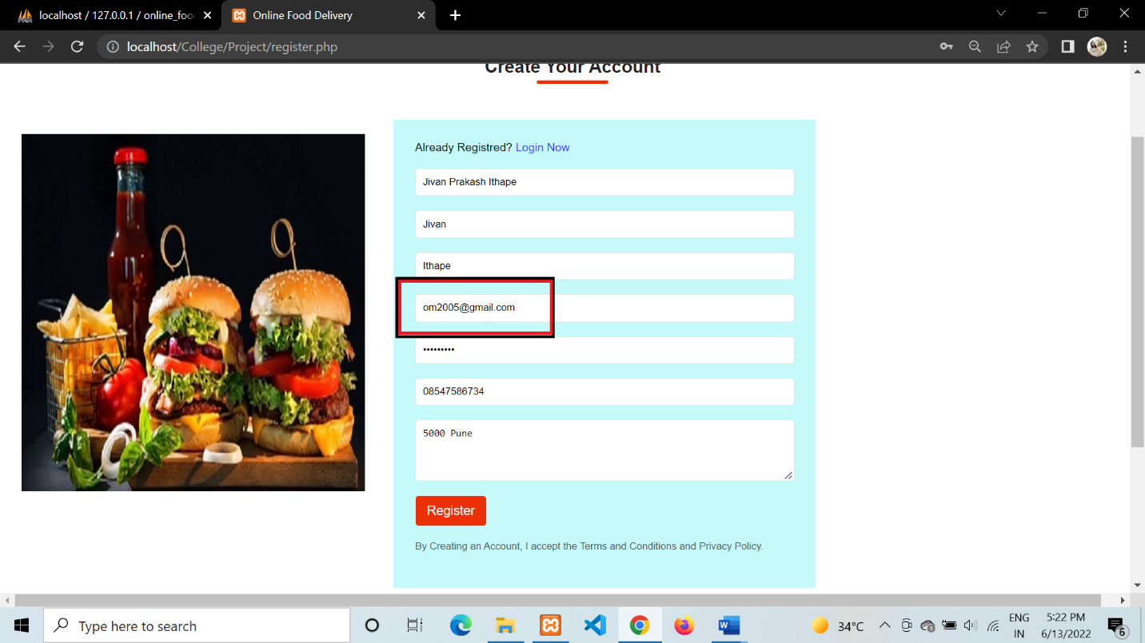

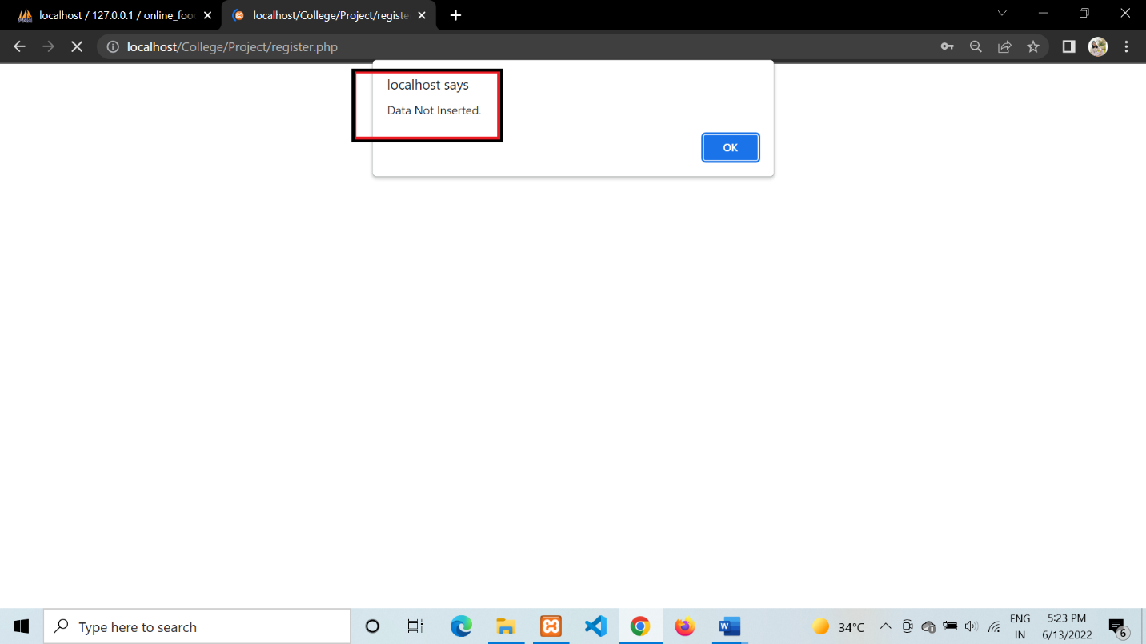

**TEST CASE - 2 USER LOGIN**

|  |  |  |  |  |  |
| --- | --- | --- | --- | --- | --- |
| SL No. | Test Cases | Result1 | Result2 | Result3 | Result4 |
| 1. | Enter Valid Username | True | True | False | False |
| 2. | Enter Valid Password | True | False | True | False |
| 3. | Final Result | Success | Fail | Fail | Fail |

**For Valid Data**

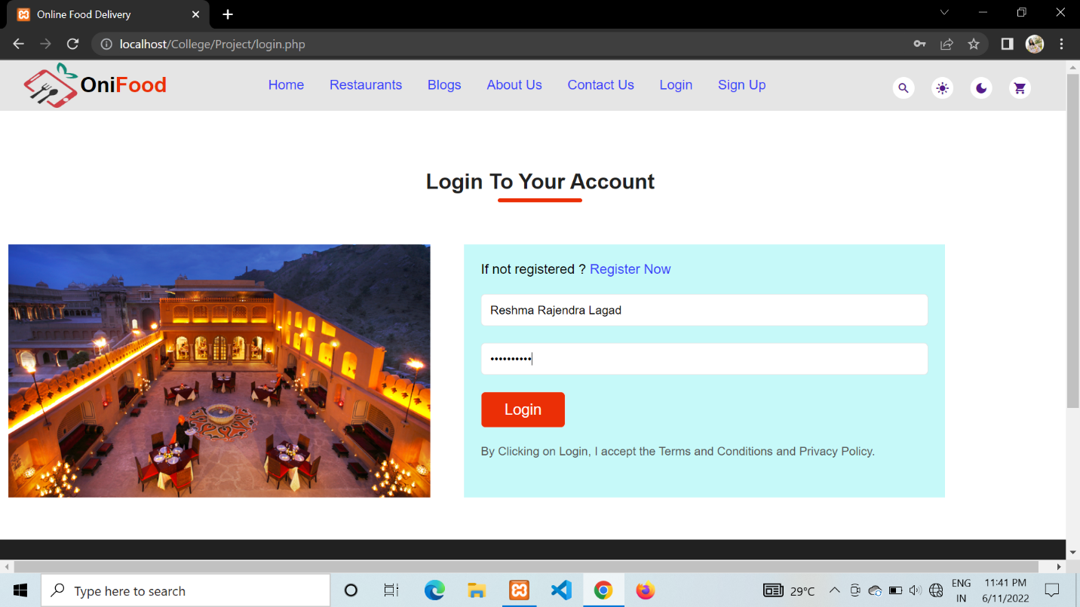

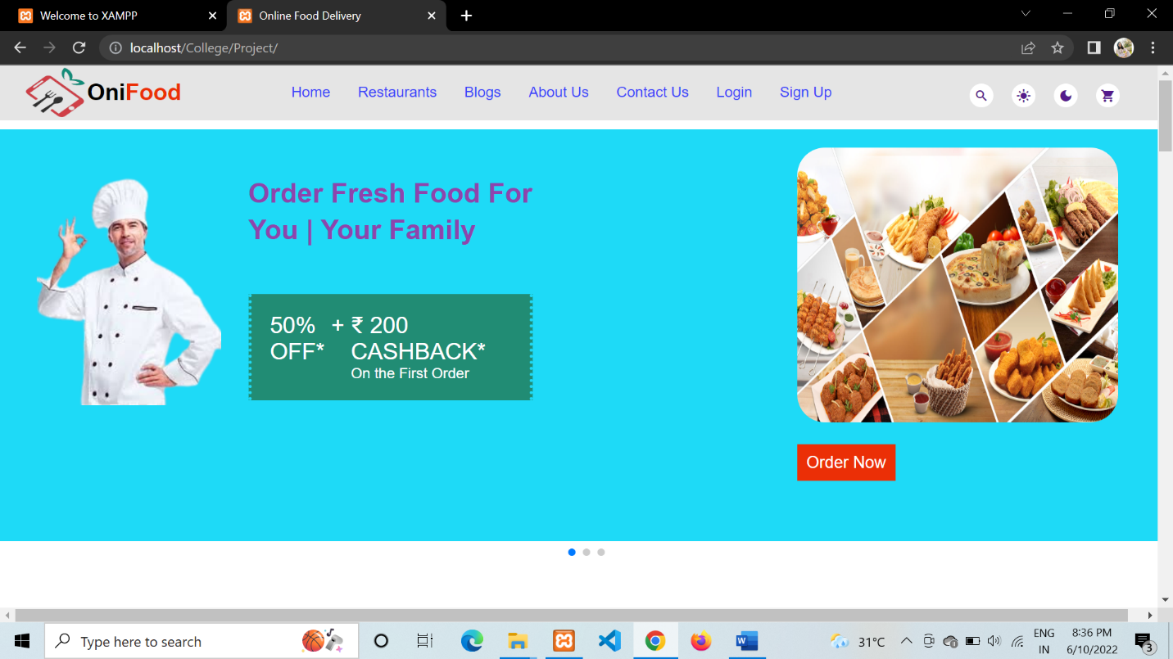

**For Invalid Data**

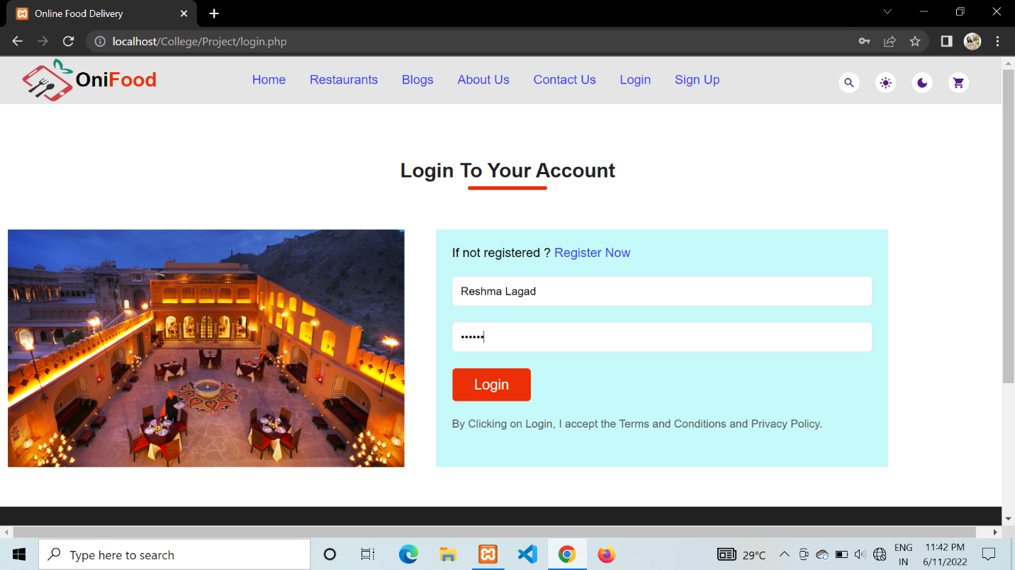

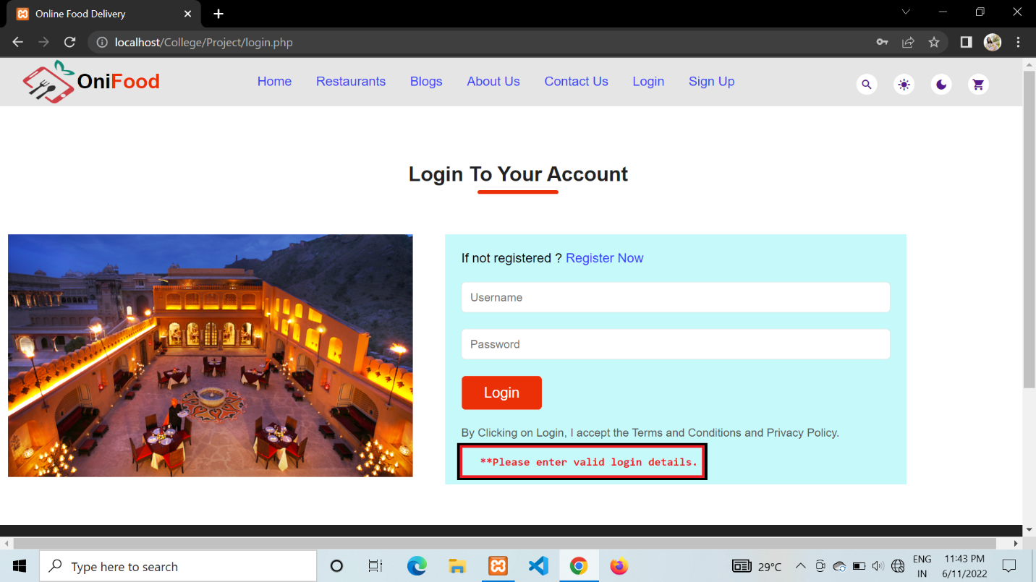

**TEST CASE - 3 ADMIN LOGIN**

|  |  |  |  |  |  |
| --- | --- | --- | --- | --- | --- |
| SL No. | Test Cases | Result1 | Result2 | Result3 | Result4 |
| 1. | Enter Valid Username | True | True | False | False |
| 2. | Enter Valid Password | True | False | True | False |
| 3. | Final Result | Success | Fail | Fail | Fail |

**For Valid data**





**For Invalid Data**

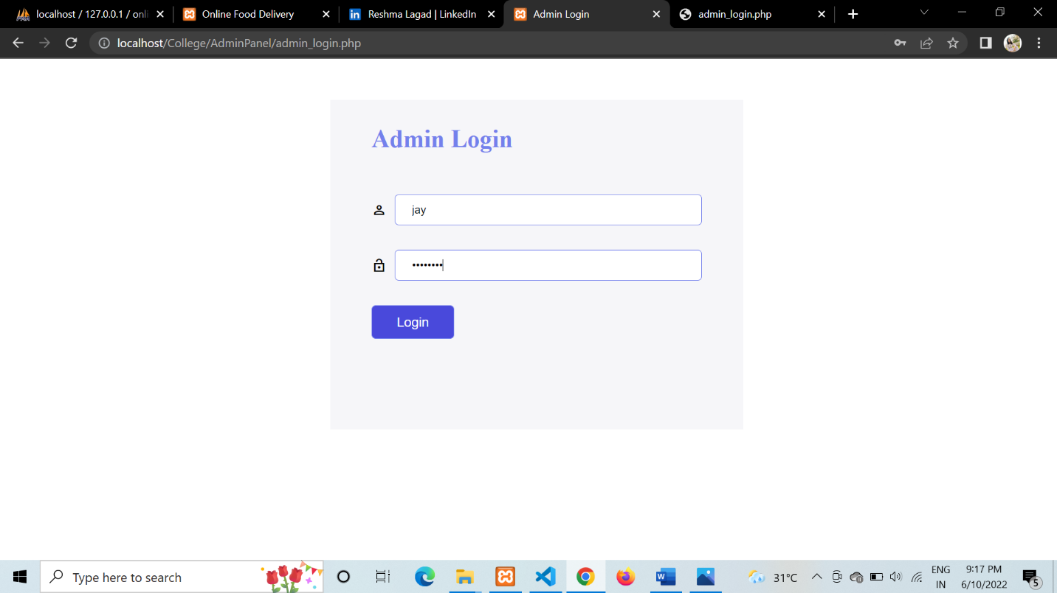

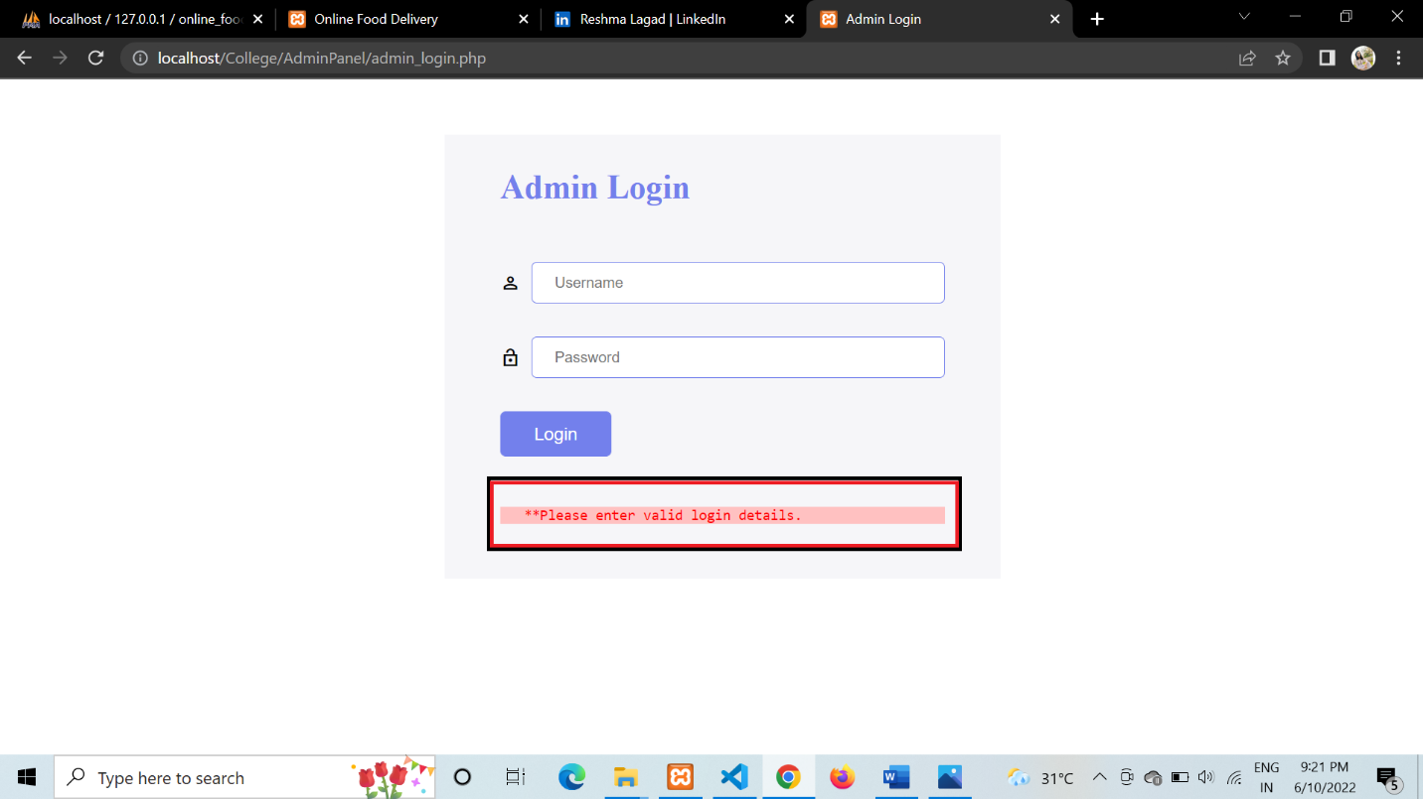

**B. WHITEBOX TESTING - TEST CASES AND RESULTS**

**TEST CASE - 1 ADD ACCOUNT**

|  |  |  |  |
| --- | --- | --- | --- |
| SL No. | Test Cases | Expected Result | Test Result |
| 1. | Enter the valid customer data. | Software should display the main menu window. | Successful |
| 2. | Invalid data. | Software will give  Error. | Successful |

**TEST CASE - 2 ADD MENU AND RESTAURANTS**

|  |  |  |  |
| --- | --- | --- | --- |
| SL No. | Test Cases | Expected Result | Test Result |
| 1. | Enter the images and names of food. | Software will show the view of menu. | Successful |
| 2. | Enter the rates of food. | Adds the rates to the menu. | Successful |
| 3. | Restaurant verification details | Verifies and scrolls to final submission. | Successful |
| 4. | Invalid verification | Closes the form and shows the home page. | Successful |
| 5. | Click on Submit Button | Opens the Menu Window | Successful |

**TEST CASE - 3 ADD TO CART**

|  |  |  |  |
| --- | --- | --- | --- |
| SL No. | Test Cases | Expected Result | Test Result |
| 1. | By Selecting ADD TO CART from the menu. | Adds the item to the cart. | Successful |
| 2. | By Clicking the Plus sign. | Adds the item one more time. | Successful |
| 3. | By Clicking Submit button. | Opens the Billing window. | Successful |
| 4. | By Clicking minus button | Deletes the number of items in the cart. | Successful |
| 5. | By Clicking Remove button | Totally removes the item from your cart. | Successful |
| 6. | By Clicking apply coupon button | Opens the text area to enter coupon. | Successful |
| 7. | By Clicking Add coupon | Adds the discount to the bill receipt. | Successful |

**TEST CASE - 4 BILL PAYMENTS**

|  |  |  |  |
| --- | --- | --- | --- |
| SL No. | Test Cases | Expected Result | Test Result |
| 1. | On the click of ADD button for cash payment option. | If a guest decides to make payment through Cash, the server should ensure the mode of payment is selected as Cash while entering the remaining Cash, if any should be given back to the guests. | Successful |
| 2. | On the click of ADD button for card payment option. | If a guest decides to make payment through Card, the server should ensure the mode of payment is selected as Card while entering and authenticated banking sites should be used. | Successful |
| 3. | On the click of ADD button for gift vouchers option. | If a guest decides to make payment through vouchers, the server should ensure that the  Vouchers are not expired | Successful |
| 4. | For some savings, click the ADD button. | Guests are offered a discount on the overall cost on numerous occasions, for example, a 10% reduction on the payment. | Successful |
| 5. | On the Click of PRINT BILL Button. | Prints the final receipt of the bill. | Successful |

**6. CONCLUSION**

* Online Food Ordering System is done to help and solve one of the important problems of customer. Because Large number of customers can use the internet and phone.
* Various issues related to Mess/Tiffin Service will be solved by these system. Thus, implementation of Online Food Ordering System is done to help and solve one of the important problem of customers.
* It helps customer in making order easily and gives information needed in making order to customer place.
* The Food website application made for restaurant and hotels massive one help to receiving orders.

**7. FUTURE SCOPES**

1. This online food delivery system project aimed at developing an

online food ordering system that can be used in small places, and

medium cities firstly and then on a large scale.

2. It is developed to help restaurants to simplify their daily operational

and managerial task as well as improve the dining experience of

customers.

3. And also helps restaurants develop healthy customer relationships by

providing good services.

4. The System enables staff to let update and make changes to their

food and beverage list information based on the orders placed and

the orders completed.

**8. BIBLIOGRAPHY AND REFERENCE**

1. "W3Schools Online Web Tutorials." <https://www.w3schools.com/>.
2. "Stack Overflow - Where Developers Learn, Share, & Build Careers." <https://stackoverflow.com/>.
3. "How to Build a Responsive Slider With Swiper.js." 28 Dec. 2021, <https://webdesign.tutsplus.com/tutorials/how-to-build-a-responsive-slider-with-swiperjs--cms-39427>.
4. "CodeWithHarry - YouTube." <https://www.youtube.com/c/CodeWithHarry>.
5. "Thapa Technical - YouTube." <https://www.youtube.com/c/ThapaTechnical>.
6. "Yahoo Baba - YouTube." <https://www.youtube.com/c/YahooBaba>.